**A Practical Activity Report for**

**MICROPROCESSOR-BASED SYSTEMS DESIGN**

**(UCS617)**

**Lab Assignment**

**Submitted by:**

**Suvansh Gupta 102103759**

**Yuvraj Singh Bath 102103771**

**Sankalp Gupta 102103784**

**Prabhmeet Kaur 102103785**

**Group: 3CO27**

**BE 3rd year**

**Submitted to:**

**Dr. Anju Bala**



**Department of Computer Science and Technology**

**Thapar Institute of Engineering and Technology,**

**Patiala, Punjab, India**

**May-2024**

# Lab Assignment-1I (Intel 8085 Microprocessor)

**INDEX**

|  |  |
| --- | --- |
| **Title** | **Page no.** |
| 1. Introduction of 8085-microprocessor kit and steps for execution on the kit. | 4 |
| 2. Familiarity with 8085-microprocessor kit.  i) Write a program to store 8-bit data into one register and then copy that to all registers.  ii) Write a program for addition of two 8-bit numbers.  iii) Write a program to add 8-bit numbers using direct and indirect addressing mode.  iv) Write a program to add 16-bit numbers using direct and indirect addressing mode.  v) Write a program to 8-bit numbers using carry. (using JNC instruction).  vi) Write a program to find 1’s complement and 2’s complement of 8-bit number. | 9  9  15  16  17  23  25 |
| 3. Write a program for the sum of series of numbers. | 28 |
| 4. Write a program for data transfer from memory block B1 to memory block B2. | 30 |
| 5. Write a program for multiply two 8-bit numbers. | 36 |
| 6. Write a program to add ten 8-bit numbers. Assume the numbers are stored in 8500-8509. Store the result in 850A and 850B memory address. | 38 |
| 7. Write a program to find the negative numbers in a block of data. | 40 |
| 8. Write a program to count the number of one's in a number. | 42 |
| 9. Write a program to arrange numbers in Ascending order. | 45 |
| 10. Calculate the sum of series of even numbers. | 50 |
| 11. Write an assembly language program to verify how many bytes are present in a given set, which resembles 10101101 in 8085. | 53 |
| 12. Write an assembly language program to find the numbers of even parity in ten consecutive memory locations in 8085. | 55 |
| 13. Write an assembly language program to convert a BCD number into its equivalent binary in 8085. | 58 |
| 14. Write an assembly language program for exchange the contents of memory location. | 62 |
| 15. Write a program to find largest element in an array of 10 elements. | 65 |

**Experiment No. 1**

**Aim:** Introduction of 8085-microprocessor kit and steps for execution on the kit.

**Introduction:**

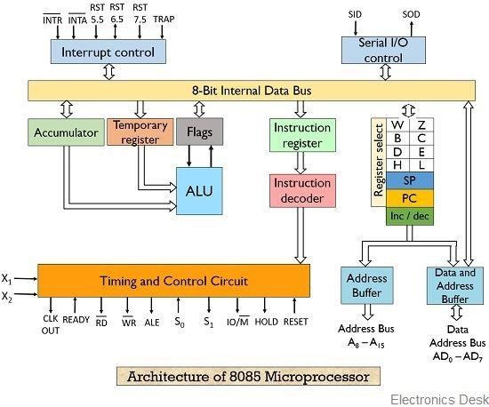

**8085 Microprocessor Block Diagram**

The Intel 8085 microprocessor is an 8-bit microprocessor introduced in 1976. It has a variety of features, including a set of flag bits that are used to indicate the status of certain operations. Here are the features of the 8085 along with its flag bits:

1. **Architecture**: The 8085 is an 8-bit microprocessor, capable of processing 8 bits of data simultaneously.

1. **Power Supply**: It operates efficiently on a single +5V D.C. supply, ensuring simplicity and ease of integration.

1. **Technolog**y: Designed utilizing NMOS technology, the 8085 integrates 6200 transistors on a single chip, enhancing efficiency and compactness.

1. **Clock Generation**: Incorporating an on-chip clock generator eliminates the need for an external clock source, streamlining system design.

1. **Clock Frequency**: The microprocessor operates at a clock frequency of 3MHz, ensuring swift execution of instructions.

1. **Address/Data Bus**: Featuring an 8-bit multiplexed address/data bus reduces the number of pins required, optimizing the design for space-constrained applications.

1. **Memory Addressing**: With 16 address lines, the 8085 can address a memory capacity of up to 64 KB, facilitating extensive memory access.

1. **I/O Port Access**: The microprocessor generates 8-bit I/O addresses, allowing access to 256 I/O ports, enhancing versatility in interfacing with external devices.

1. **Interrupts**: Equipped with 5 hardware interrupts (TRAP/RST4.5, RST 7.5, RST 6.5, RST

5.5, and INTR), enabling efficient handling of external events.

1. **DMA Support**: The provision of Direct Memory Access (DMA) enhances data transfer efficiency, particularly in high-throughput applications.

1. **Package**: Housed in a 40-pin IC package, the 8085 is fabricated on a single Large-Scale Integration (LSI) chip, ensuring ease of installation and maintenance.

1. **Clock Cycle**: With a clock cycle of 320ns, the microprocessor delivers reliable and rapid computation capabilities.

1. **Instruction Se**t: The 8085 boasts an extensive instruction set, comprising 80 basic instructions and 246 opcodes, catering to diverse computational requirements.

Overall, the 8085 microprocessor, with its rich instruction set and flag register, was widely used in various applications, including embedded systems, industrial control, and early personal computers.

**Special Key Functions:**

1. **- The Reset key** in Vikas Simulator serves a critical role in setting the program's execution state back to its initial conditions. Here's a detailed explanation of its functionality and significance:

**Function:**

Pressing the Reset key essentially restarts the program simulation, simulating a power-on or system reset event.

This action brings the program's execution environment back to its initial state, as defined when the program was loaded or last reset.

1. **- The Kbint key** in Vikas Simulator serves a specific purpose related to keyboard input simulation within the program execution. Here's a breakdown of its functionality and how it can be used:

**Function:**

Pressing the Kbint key opens a dialog box or prompt where you can enter a sequence of characters to be simulated as keyboard input for the program.

This essentially injects the entered characters into the program's input stream,

1. **- The Prev key** in the Vikas Simulator serves the purpose of navigating backwards within the program's execution. Here's a detailed explanation of its functionality:

**Function:**

When pressed, the Prev key takes you one step back in the program's execution.

This essentially means it reverses the execution of the most recently executed instruction.

1. **- The exm Mem key** in the Vikas Simulator allows users to inspect the contents of memory locations in a simulated environment.

**Function:**

The "exm Mem" function, short for "Examine Memory," allows users to inspect and analyze the contents of memory locations during program execution in the Vikas Simulator for the 8085

microprocessor.

1. **- The Next key** in Vikas Simulator plays a vital role in controlling the program execution, allowing you to move forward one step at a time. Here's a breakdown of its functionality and significance:

**Function:**

Pressing the Next key advances the program execution by one instruction.

This essentially simulates the normal execution flow, where the processor fetches, decodes, and executes the next instruction in sequence.

1. **- The exm Reg** in Vikas Simulator allows users to inspect the contents of the various registers within the simulated microprocessor.

**Function:**

The "exm Reg" function, short for "Examine Register," allows users to inspect and analyze the contents of the various registers within the simulated 8085 microprocessor in Vikas Simulator.

1. **- The Go key** in Vikas Simulator serves a distinct purpose compared to the Prev and Next keys, focusing on continuous execution rather than step-by-step control. Here's a detailed explanation of its functionality:

**Function:**

Pressing the Go key initiates the uninterrupted execution of the entire program from the current point.

Unlike the Next key, which advances one instruction at a time, the Go key allows the program to run without pausing until it reaches the end or encounters an error.

1. **- The Exec key** in Vikas Simulator holds a specific purpose within the program execution process. Here's a breakdown of its functionality and significance:

**Function:**

Pressing the Exec key directly executes the entire program from the beginning, similar to pressing the Go key.

However, the key distinction lies in its behavior regarding breakpoints.

**Vikas Simulator:**

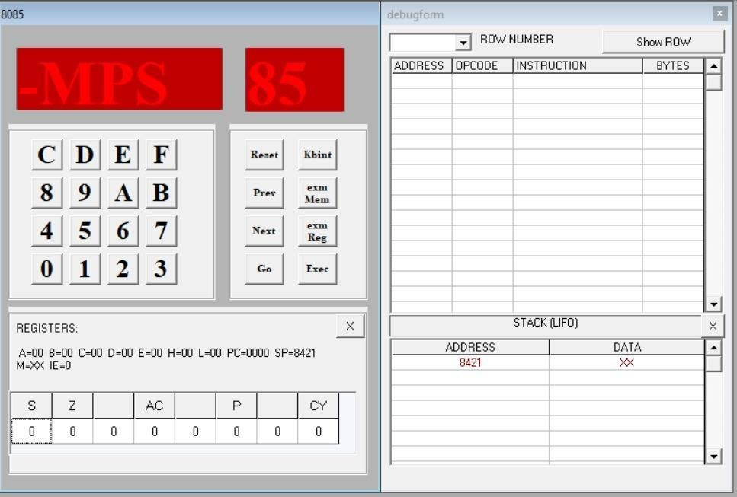

## Vikas Simulator Screenshot

The Vikas Simulator is a software tool that allows you to simulate the execution of 8085 microprocessor programs. It provides a graphical user interface (GUI) that includes a code editor, a debugger, and a memory viewer. You can use the code editor to write and assemble 8085 assembly language programs. The debugger allows you to step through your program line by line, and the memory viewer allows you to see the contents of memory at any point in time.

The Vikas Simulator is a useful tool for learning about the 8085 microprocessor and for debugging 8085 assembly language programs. It is easy to use and has a wide range of features.

**Steps to run the program:**

1. Press Reset
2. Press Examine Memory
3. Enter starting address
4. Press Next
5. Enter opcodes by subsequently pressing Next
6. Press Reset
7. Press Go
8. Enter starting address of the program to compile
9. Press EXEC/FILL
10. Press Reset
11. Press Examine Memory
12. Enter Output Address
13. Press Next

## Program 2.1

**Aim: Write a program to store 8-bit data into one register and then copy that to all registers**

|  |  |  |
| --- | --- | --- |
| **Code** | **Memory Location** | **Opcode** |
| MVI A, 48 | 8000, 8001 | 3E, 48 |
| MOV B, A | 8002 | 47 |
| MOV C, A | 8003 | 4F |
| MOV D, A | 8004 | 57 |
| MOV E, A | 8005 | 5F |
| MOV H, A | 8006 | 67 |
| MOV L, A | 8007 | 6F |
| RST 5 | 8008 | EF |

## Instruction set

**Output**

A – 48, B – 48, C – 48, D – 48, E – 48, H – 48, L – 48

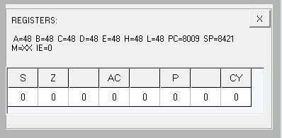

## Flag register output

**Code execution**

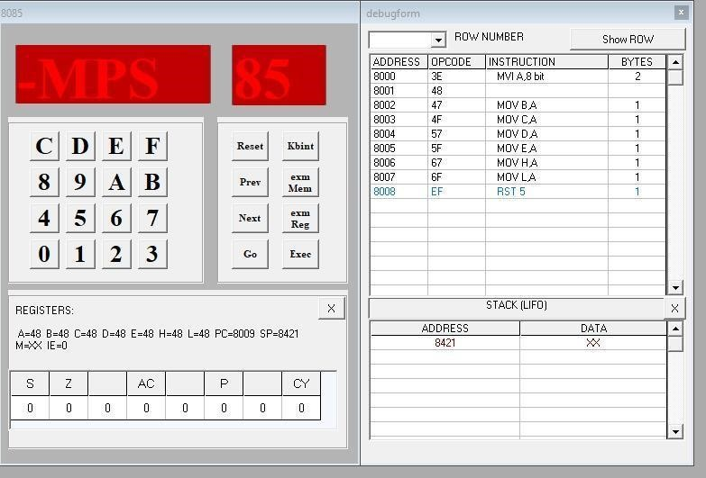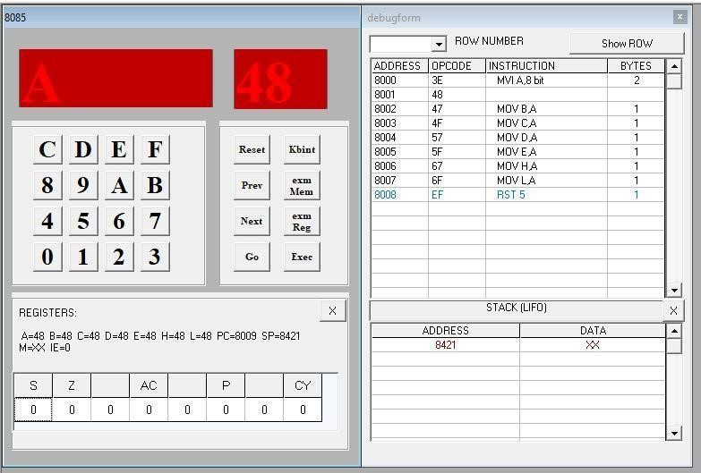

**Accumulator Output**

**Output at register B**

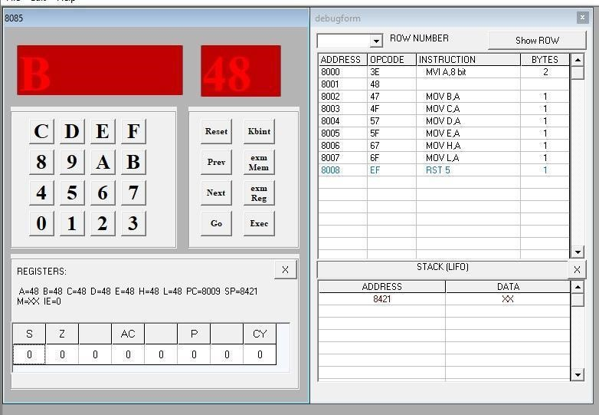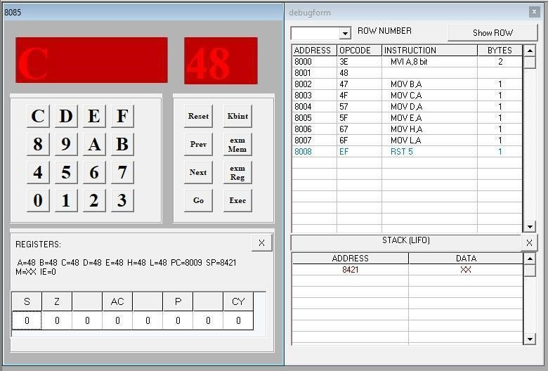

**Output at register C**

**Output at register D**

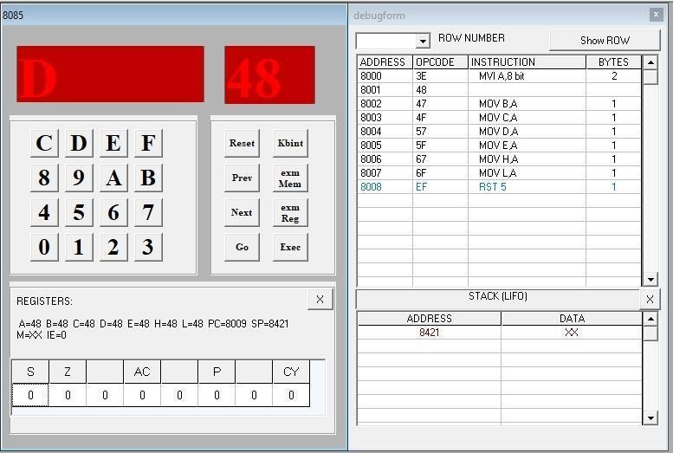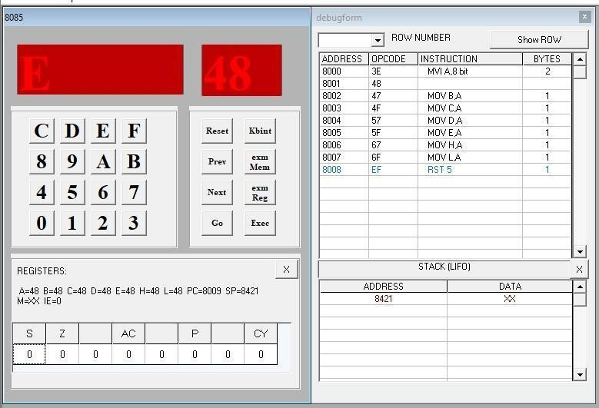

**Output at register E**

**Output at register H**

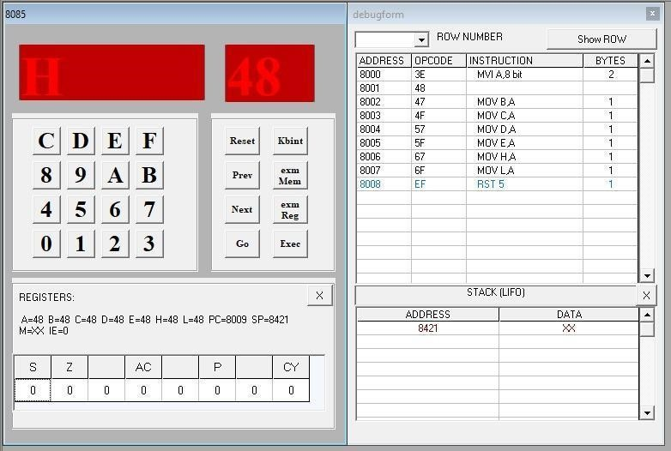

**Output at register L**

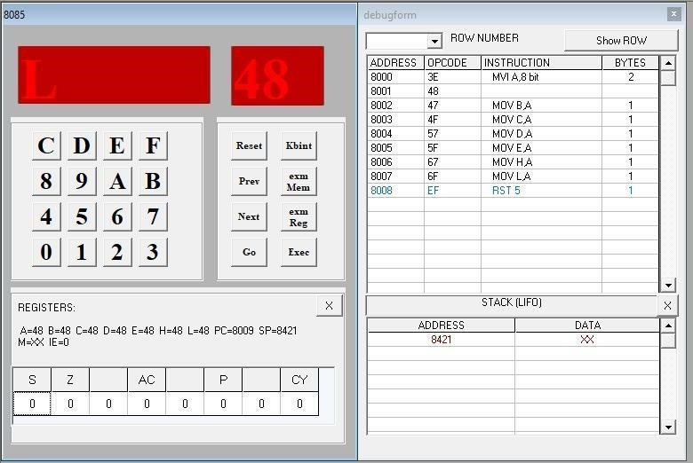

**Program 2.2 Aim: Write a program for addition of two 8-bit numbers.**

|  |  |  |
| --- | --- | --- |
| **Code** | **Memory Location** | **Opcode** |
| MVI A, 48 | 8000, 8001 | 3E, 48 |
| MVI B, 48 | 8002, 8003 | 06, 48 |
| ADD B | 8004 | 80 |
| STA 8500 | 8005, 8006, 8007 | 32, 00, 85 |
| RST 5 | 8008 | EF |

**Instruction set**

**Output**

[ 8500 ] – 90

**Flag register output**

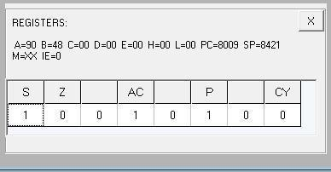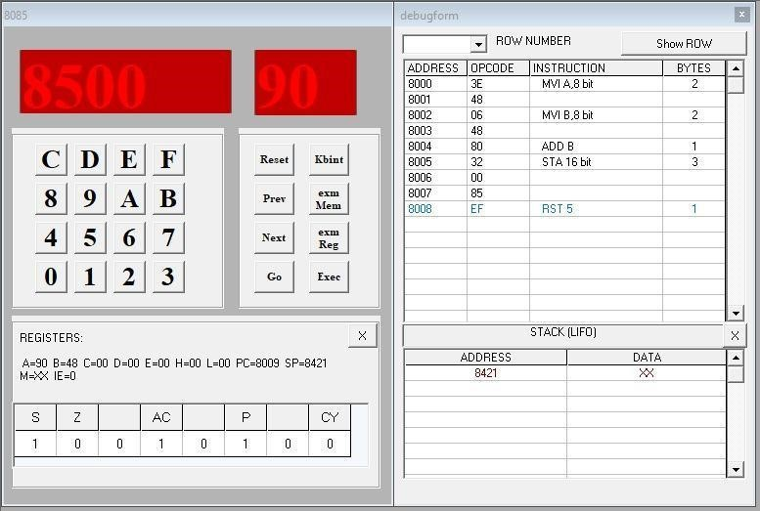

**Output at memory location 8500**

## Program 2.3

**Aim: Write a program to add 8-bit numbers using direct and indirect addressing mode.**

|  |  |  |
| --- | --- | --- |
| **Code** | **Memory Location** | **Opcode** |
| LDA 8500 | 8000, 8001, 8002 | 3A, 00, 85 |
| MOV B, A | 8003 | 47 |
| LDA 8501 | 8004, 8005, 8006 | 3A, 01, 85 |
| ADD B | 8007 | 80 |
| STA 8502 | 8008, 8009, 800A | 32, 02, 85 |
| RST 5 | 800B | EF |

## Instruction set for direct addressing mode

**Input**

[ 8500 ] – 88, [ 8501 ] – 88

**Output**

[ 8502 ] – 10

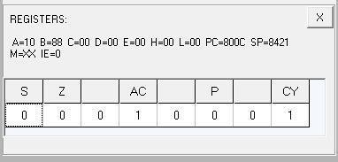

## Flag register output

**Output at memory location 8502**

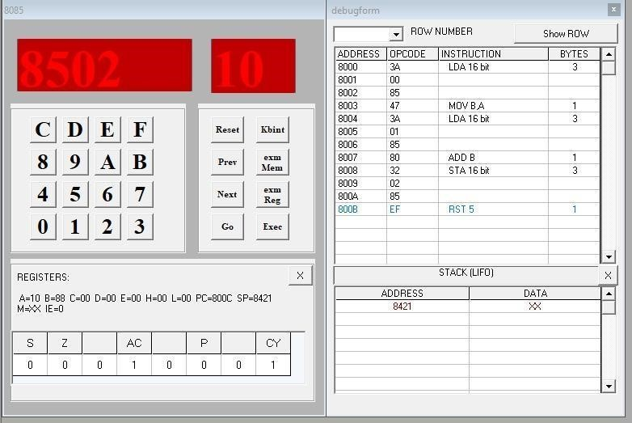

|  |  |  |
| --- | --- | --- |
| **Code** | **Memory Location** | **Opcode** |
| LXI H, 8500 | 8000, 8001, 8002 | 21, 00, 85 |
| MOV A, M | 8003 | 7E |
| INX H | 8004 | 23 |
| ADD M | 8005 | 86 |
| INX H | 8006 | 23 |
| MOV M, A | 8007 | 77 |
| RST 5 | 8008 | EF |

**Instruction set for indirect addressing mode**

**Input**

[ 8500 ] – 88, [ 8501 ] – 88

**Output** A – 10

**Flag registers output**

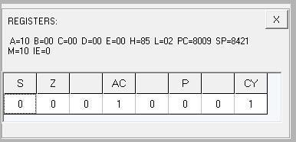

**Output at Accumulator**

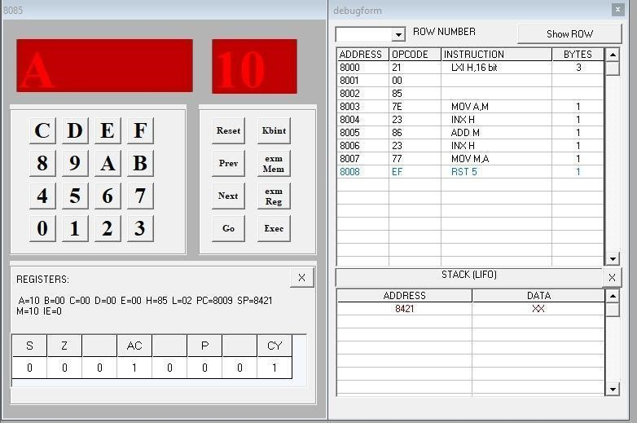

## Program 2.4

**Aim: Write a program to add 8-bit numbers using direct and indirect addressing mode.**

|  |  |  |
| --- | --- | --- |
| **Code** | **Memory Location** | **Opcode** |
| LHLD 8500 | 8000, 8001, 8002 | 2A, 00, 85 |
| XCHG | 8003 | EB |
| LHLD 8502 | 8004, 8005, 8006 | 2A, 02, 85 |
| DAD D | 8007 | 19 |
| SHLD 8504 | 8008, 8009, 800A | 22, 04, 85 |
| RST 5 | 800B | EF |

## Instruction set for direct addressing mode

**Input**

[ 8500 ] – 48, [ 8501 ] – 48, [ 8502 ] – 48, [ 8503 ] – 48

**Output**

[ 8504 ] – 90, [ 8505 ] – 90

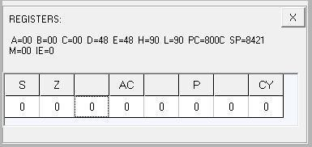

## Flag register output

**Output at memory**

**location 8504**

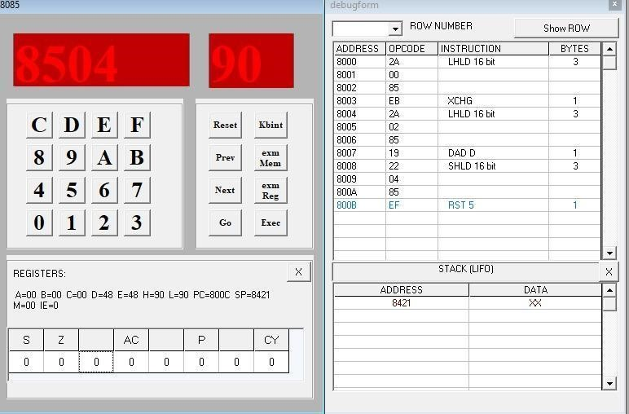

**Output at memory location 8505**

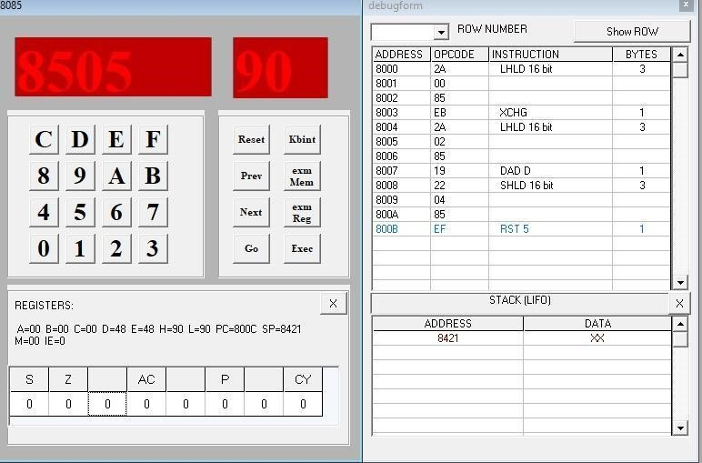

|  |  |  |
| --- | --- | --- |
| **Code** | **Memory Location** | **Opcode** |
| LXI B, 8500 | 8000, 8001, 8002 | 01, 00, 85 |
| LDAX B | 8003 | 0A |
| MOV D, A | 8004 | 57 |
| INX B | 8005 | 03 |
| LDAX B | 8006 | 0A |
| ADD D | 8007 | 82 |
| STA 8504 | 8008, 8009, 800A | 32, 04 ,85 |
| INX B | 800B | 03 |
| LDAX B | 800C | 0A |
| MOV D, A | 800D | 57 |
| INX B | 800E | 03 |
| LDAX B | 800F | 0A |
| ADC D | 8010 | 8A |
| STA 8505 | 8011, 8012, 8013 | 32, 05, 85 |
| RST 5 | 8014 | EF |

**Instruction set for indirect addressing mode**

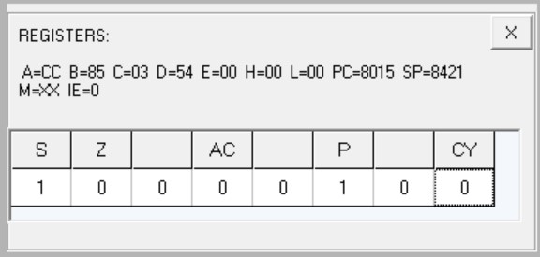

**Flag register output**

**Output at memory location 8504**

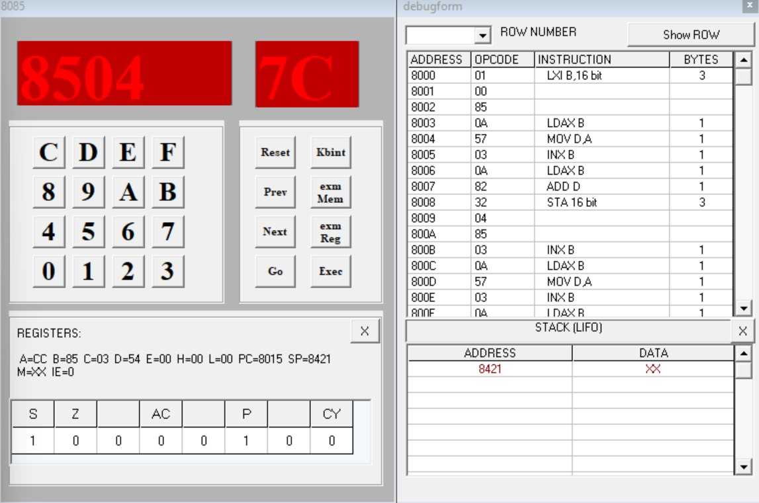

**Output at**

**memory location 8505**

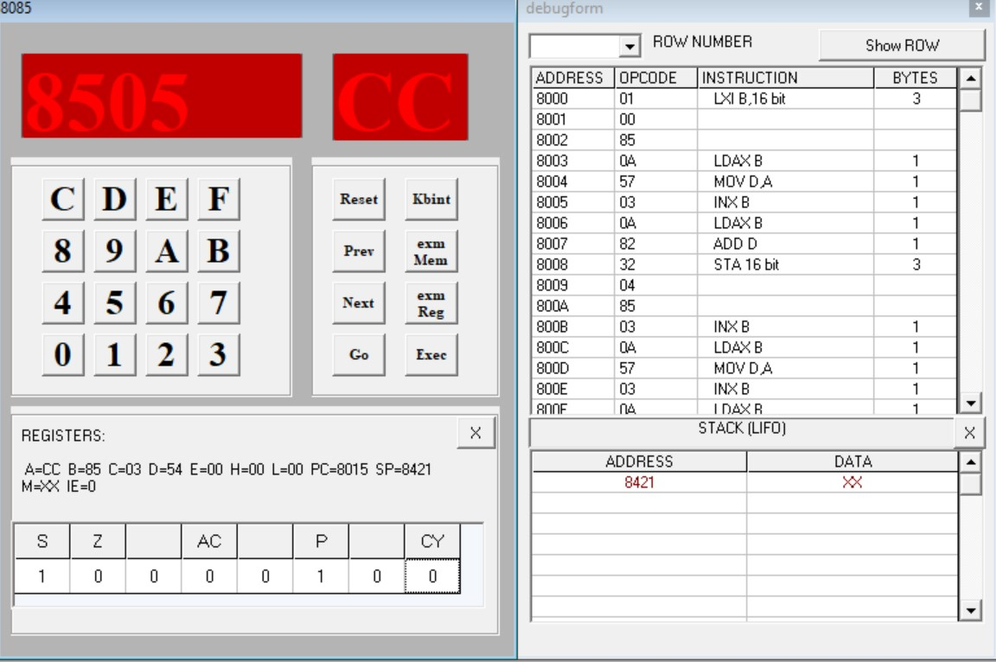

## Program 2.5

**Aim: Write a program to add 8-bit numbers using carry. (using JNC instruction)**

|  |  |  |
| --- | --- | --- |
| **Code** | **Memory Location** | **Opcode** |
| MVI C, 00 | 8000, 8001 | 0E, 00 |
| LXI H, 8500 | 8002, 8003, 8004 | 21, 00, 85 |
| MOV A, M | 8005 | 7E |
| INX H | 8006 | 23 |
| ADD M | 8007 | 86 |
| JNC Next | 8008, 8009, 800A | D2, 0C, 80 |
| INR C | 800B | 0C |
| Next: INX H | 800C | 23 |
| MOV M, A | 800D | 77 |
| INX H | 800E | 23 |
| MOV M, C | 800F | 71 |
| RST 5 | 8010 | EF |

## Instruction set

**Input**

[8500] – 88, [8501] – 88

**Output**

[8502] – 10, [8503] - 01

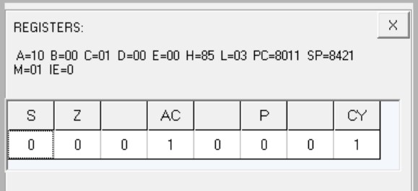

## Flag register output

**Output at memory location 8502**

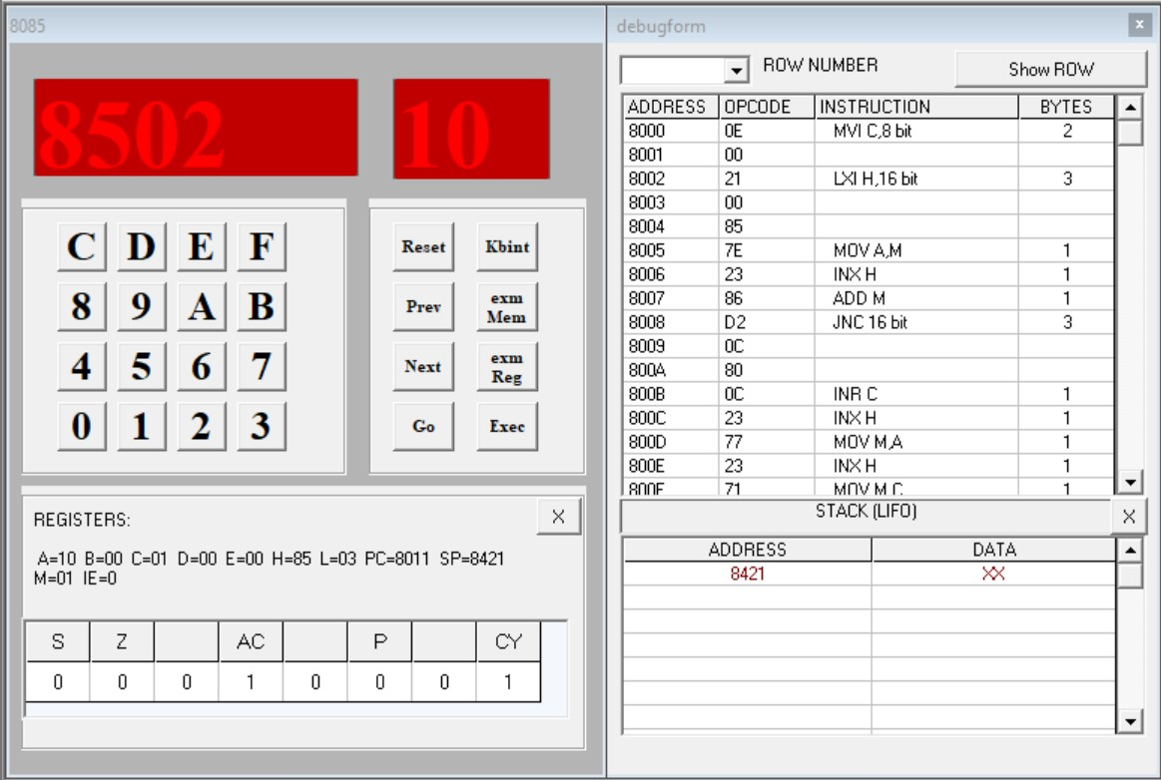

**Output at memory location 8503**

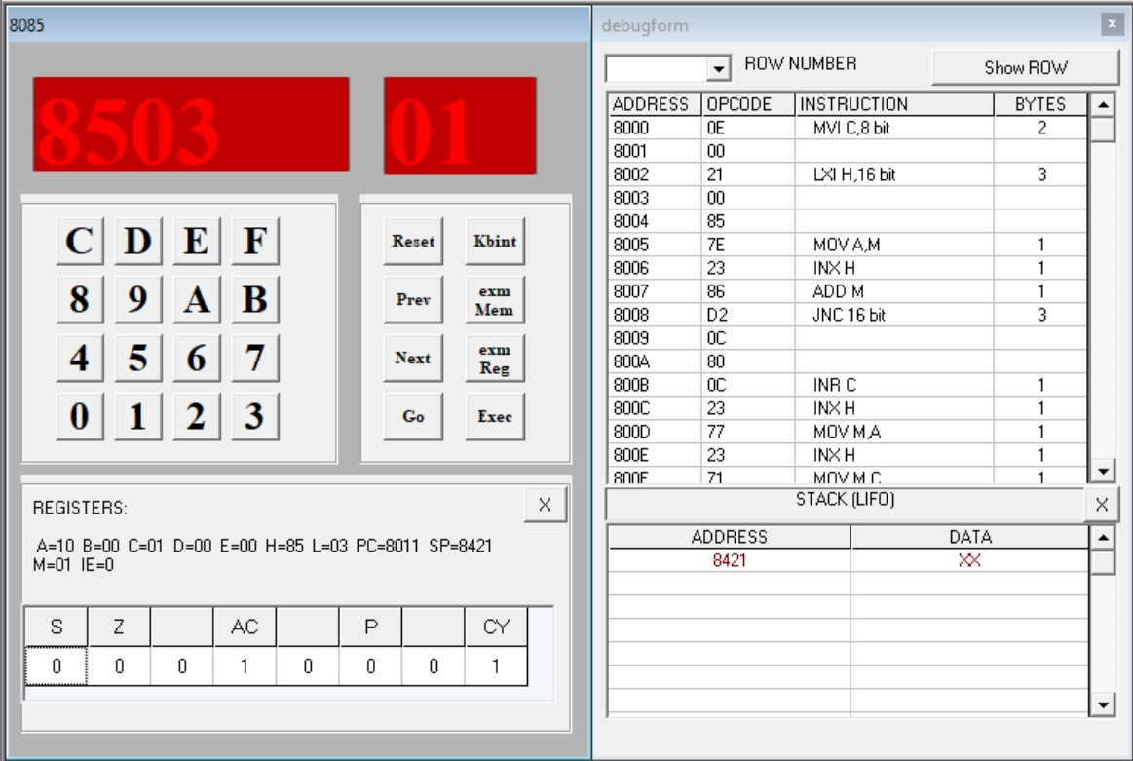

## Program 2.6

**Aim: Write a program to find 1’s complement and 2’s complement of a 8-bit number.**

|  |  |  |
| --- | --- | --- |
| **Code** | **Memory Location** | **Opcode** |
| LDA 8500H | 8000, 8001, 8002 | 3A, 00, 85 |
| CMA | 8003 | 2F |
| STA 8501H | 8004, 8005, 8006 | 32, 01, 85 |
| RST 5 | 8007 | EF |

## Instruction set for 1’s complement

**Input** [8500] – 48

**Output**

[8501] – B7

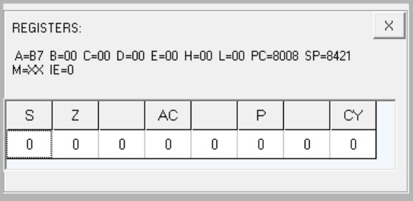

## Flag register output

**Output at memory location 8501**

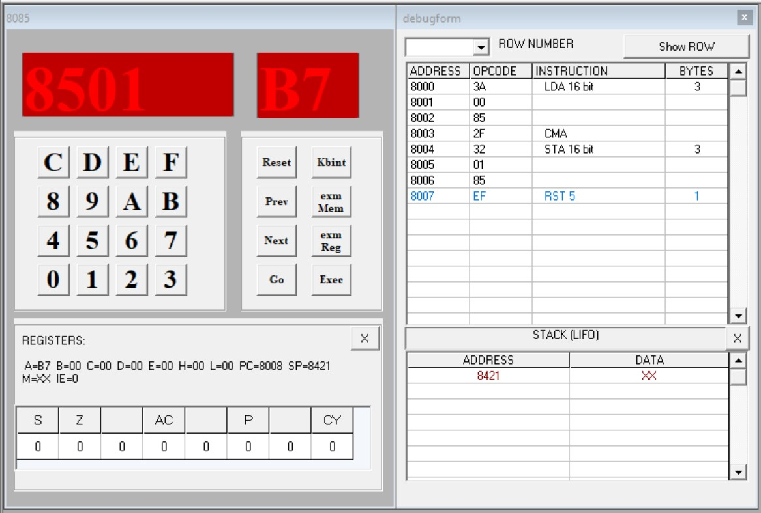

|  |  |  |
| --- | --- | --- |
| **Code** | **Memory Location** | **Opcode** |
| LDA 8500H | 8000, 8001, 8002 | 3A, 00, 85 |
| CMA | 8003 | 2F |
| INR A | 8004 | 3C |
| STA 8501H | 8005, 8006, 8007 | 32, 01, 85 |
| RST 5 | 8008 | EF |

**Instruction set for 2’s complement**

**Input** [8500] – 48

**Output**

[8501] – B8

**Flag register output**

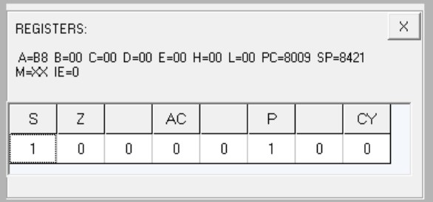

**Output at memory location 8501**

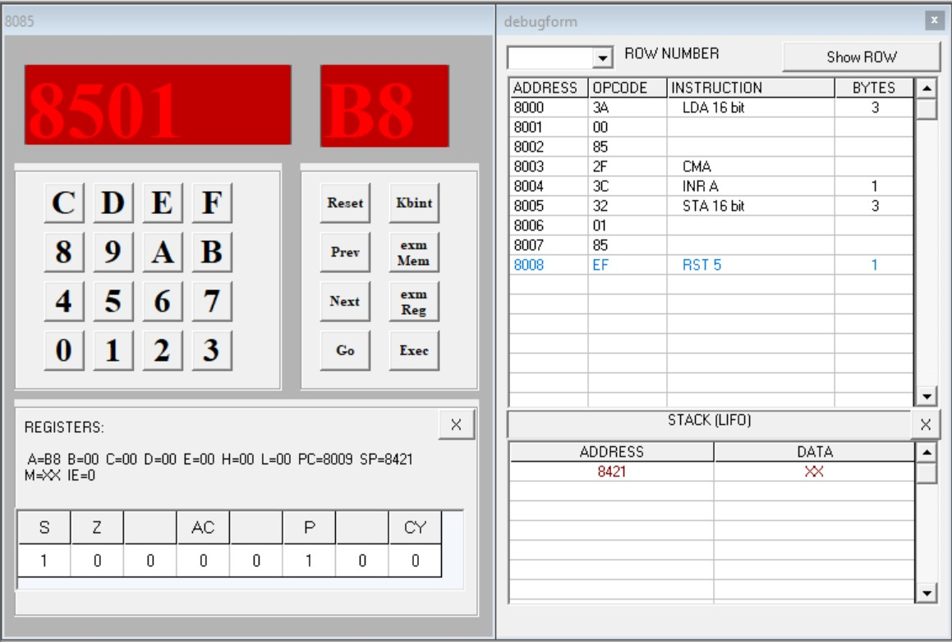

**Program 3**

**Aim: Write a program for the sum of series of numbers.**

|  |  |  |
| --- | --- | --- |
| **Code** | **Memory Location** | **Opcode** |
| LDA 8500H | 8000, 8001, 8002 | 3A, 00, 85 |
| MOV C, A | 8003 | 4F |
| SUB A | 8004 | 97 |
| LXI H, 8501H | 8005, 8006, 8007 | 21, 01, 85 |
| Back: ADD M | 8008 | 86 |
| INX H | 8009 | 23 |
| DCR C | 800A | 0D |
| JNZ Back | 800B, 800C, 800D | C2, 08, 80 |
| STA 8600H | 800E, 800F, 8010 | 32, 00, 86 |
| RST 5 | 8011 | EF |

**Instruction set**

**Input**

[8500] – 04, [8501] – 9A, [8502] – 52, [8503] – 89, [8504] – 3E

**Output**

[8600] – B3

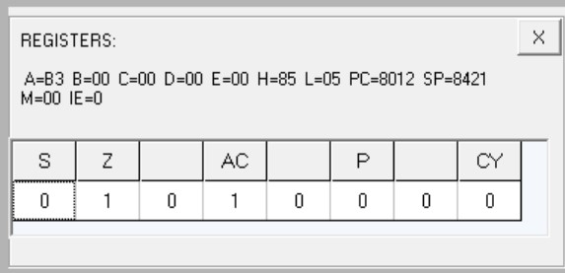

**Flag register output**

**Output at memory location 8600**

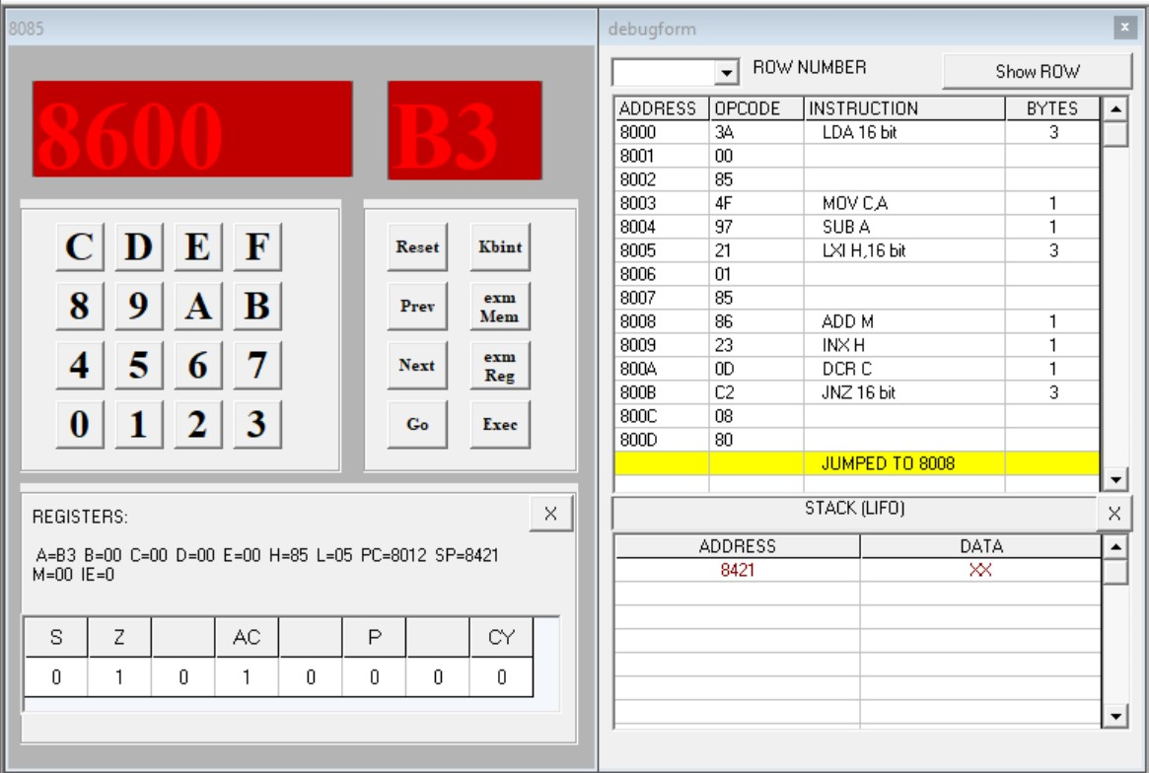

**Program 4**

**Aim: Write a program for data transfer from memory block B1 to memory block B2.**

|  |  |  |
| --- | --- | --- |
| **Code** | **Memory Location** | **Opcode** |
| MVI C, 0AH | 8000,8001 | 0E, 0A |
| LXI H, 8500H | 8002, 8003, 8004 | 21, 00, 85 |
| LXI D, 8600H | 8005, 8006, 8007 | 11, 00, 86 |
| Back: MOV A, M | 8008 | 7E |
| STAX D | 8009 | 12 |
| INX H | 800A | 23 |
| INX D | 800B | 13 |
| DCR C | 800C | 0D |
| JNZ Back | 800D, 800E, 800F | C2, 08, 80 |
| RST 5 | 8010 | EF |

## Instruction set

**Input**

[8500] – 01, [8501] – 02, [8502] – 03, [8503] – 04, [8504] – 05, [8505] – 06, [8506] – 07,

[8507] – 08, [8508] – 09, [8509] – 0A

**Output**

[8600] – 01, [8601] – 02, [8602] – 03, [8603] – 04, [8604] – 05, [8605] – 06, [8606] – 07, [8607] – 08, [8608] – 09, [8609] – 0A

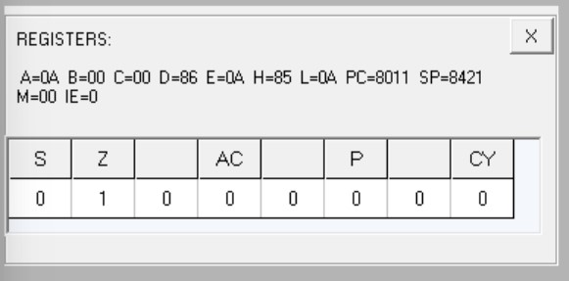

## Flag register output

**Output at memory location 8600**

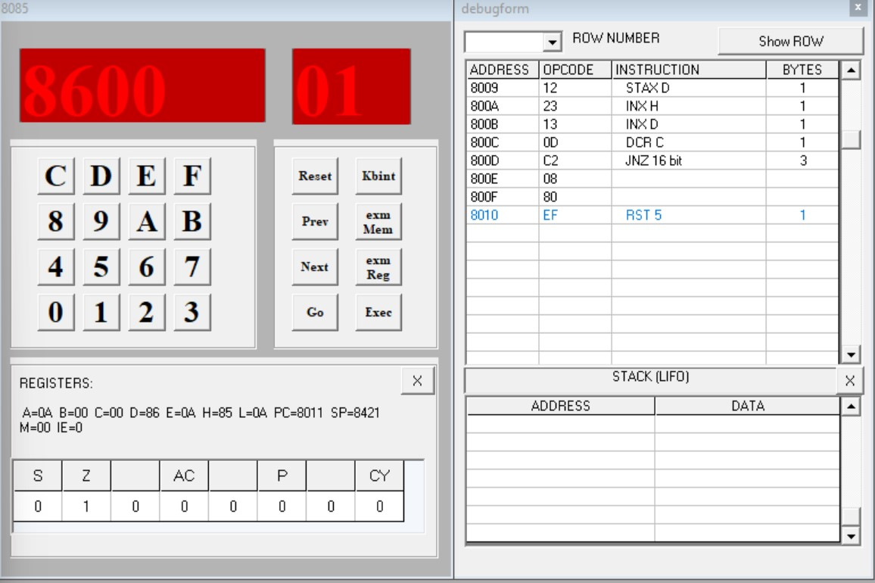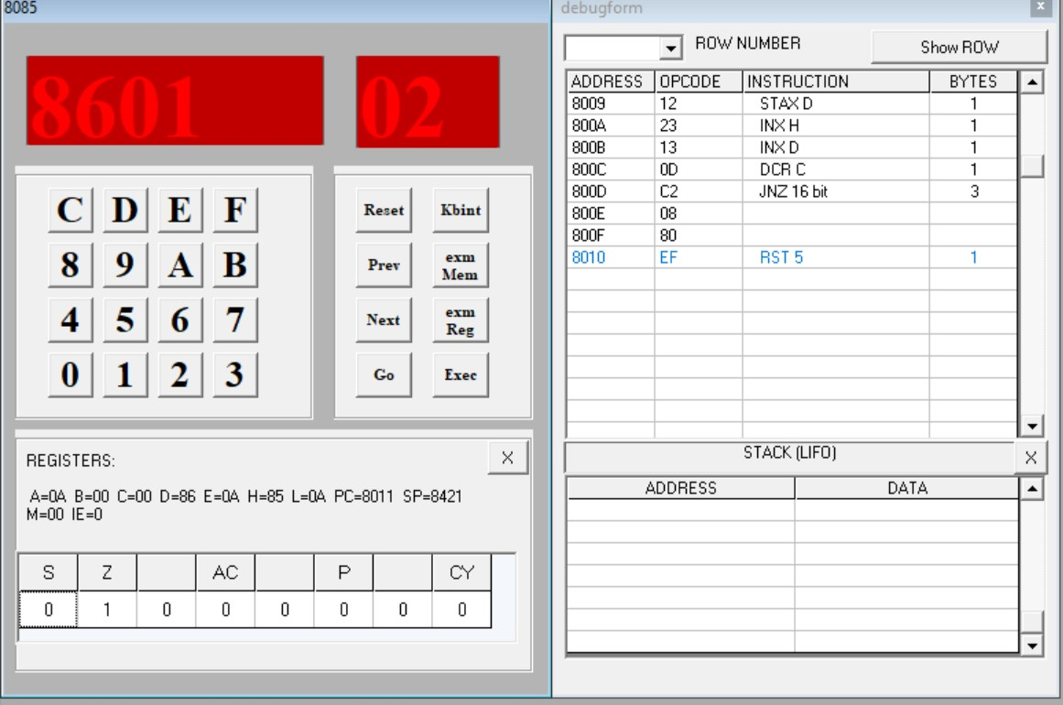

**Output at memory location 8601**

**Output at**

**memory location 8602**

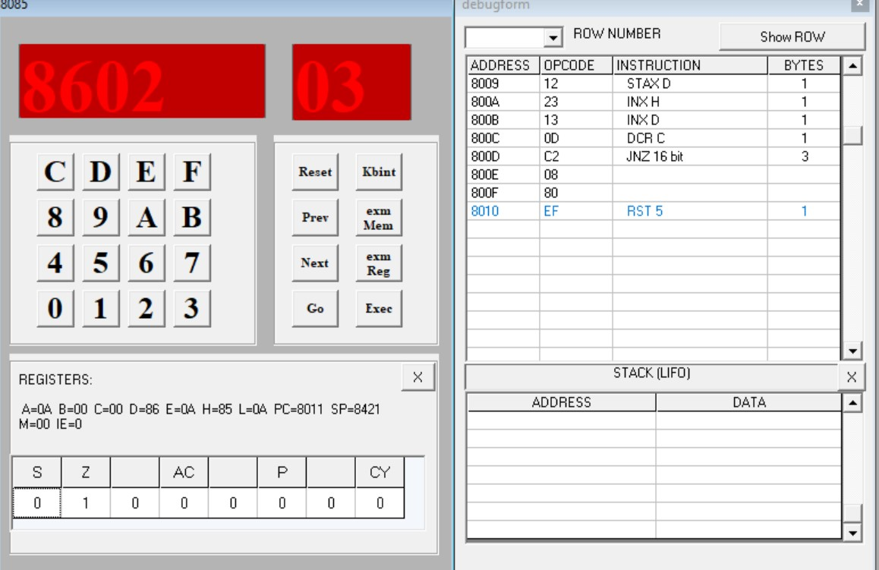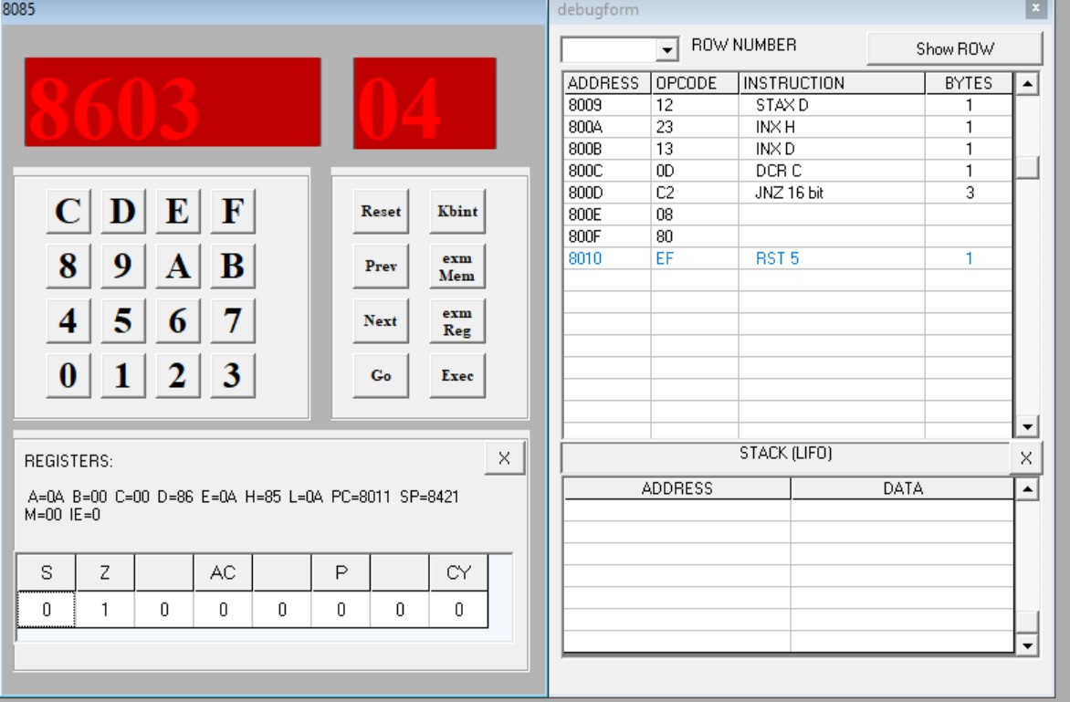

**Output at memory location 8603**

**Output at memory location 8604**

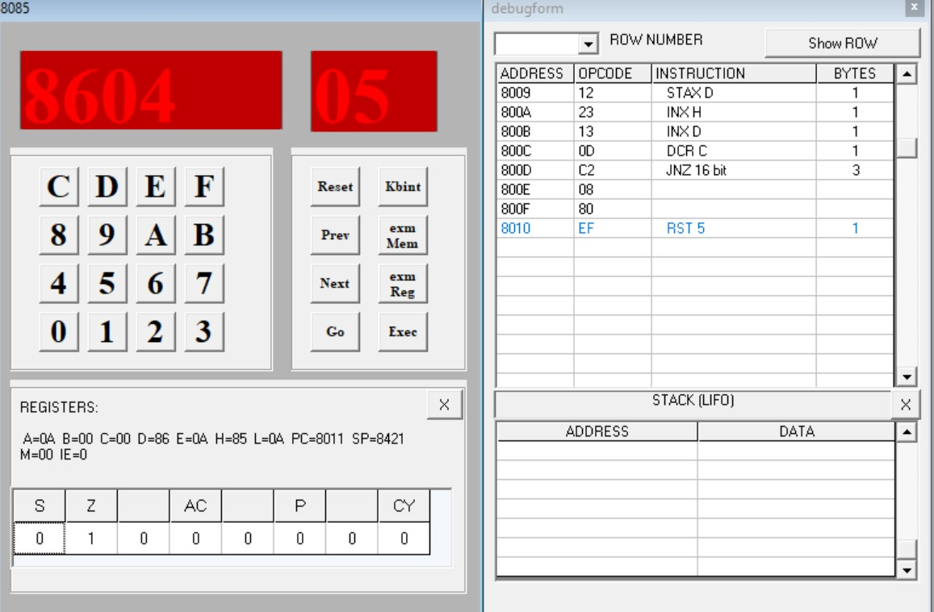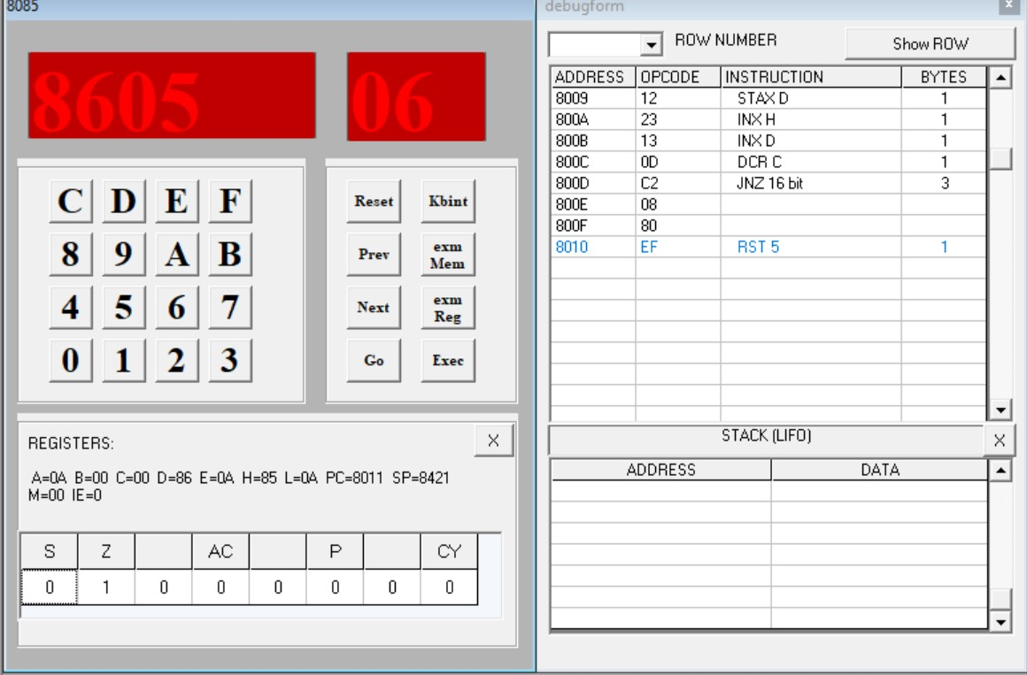

**Output at memory location 8605**

**Output at memory location 8606**

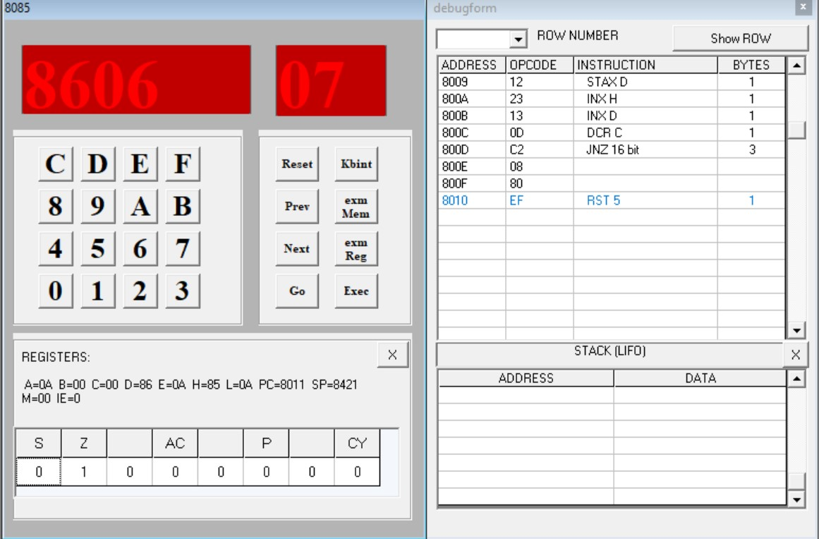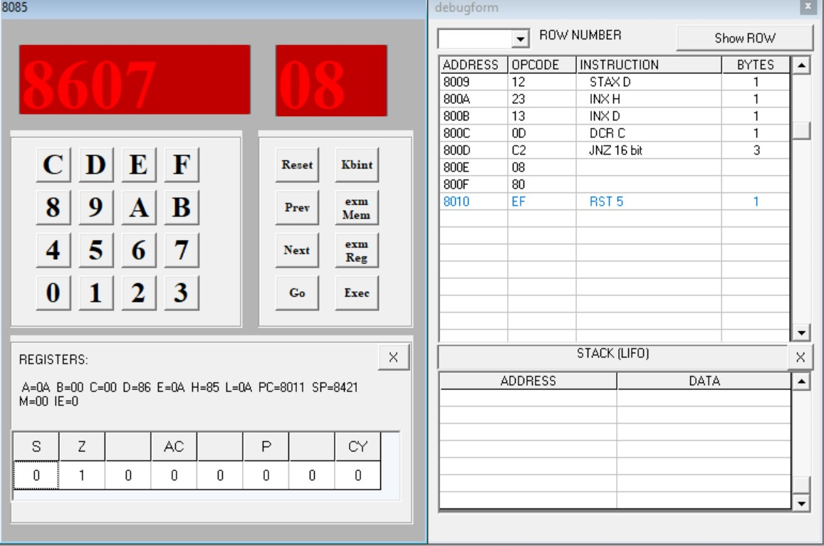

**Output at memory location 8607**

**Output at memory location 8608**

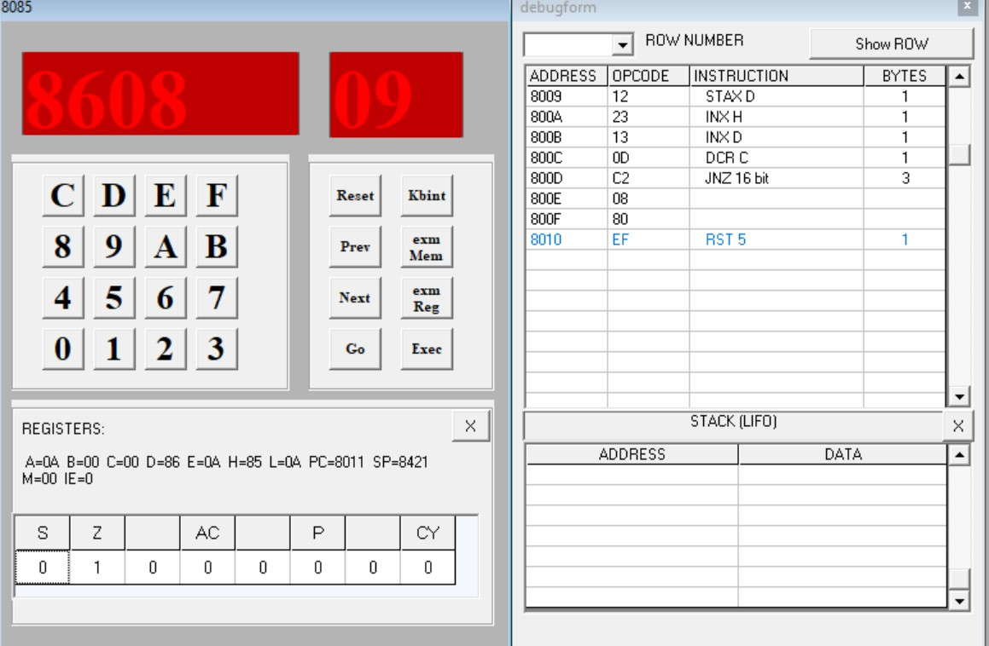

**Output at memory location 8609**

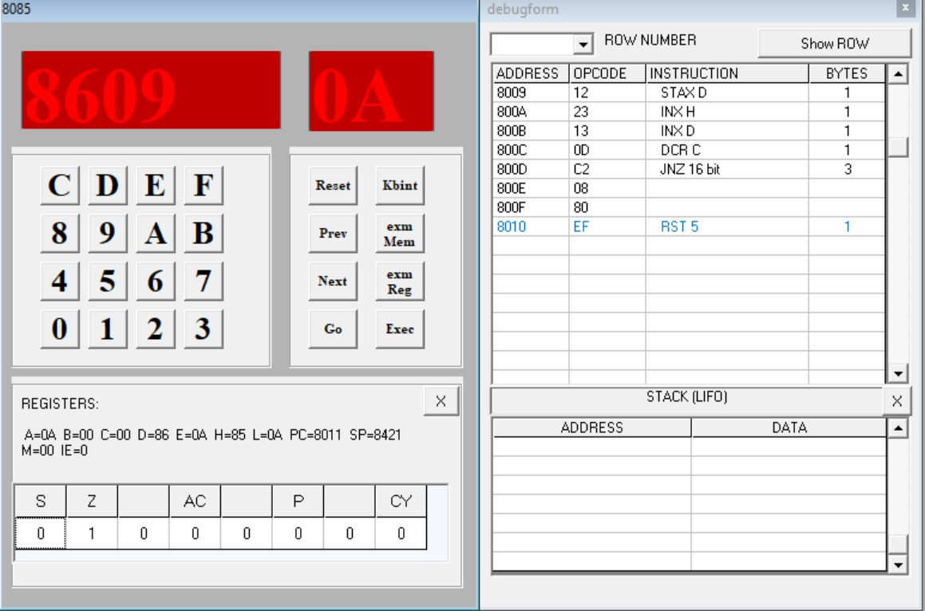

**Program 5**

**Aim: Write a program to multiply two 8-bit numbers.**

|  |  |  |
| --- | --- | --- |
| **Code** | **Memory Location** | **Opcode** |
| LDA 8500H | 8000, 8001, 8002 | 3A, 00, 85 |
| MOV E, A | 8003 | 5F |
| MVI D, 00 | 8004, 8005 | 16, 00 |
| LDA 8501H | 8006, 8007, 8008 | 3A, 01, 85 |
| MOV C, A | 8009 | 4F |
| LXI H, 0000H | 800A, 800B, 800C | 21, 00, 00 |
| Back: DAD D | 800D | 19 |
| DCR C | 800E | 0D |
| JNZ Back | 800F, 8010, 8011 | C2, 0D, 80 |
| SHLD 8600H | 8012, 8013, 8014 | 22, 00, 86 |
| RST 5 | 8015 | EF |

**Instruction set**

**Input**

[8500] – B2, [8501] – 03

**Output**

[8600] – 16, [8601] – 02

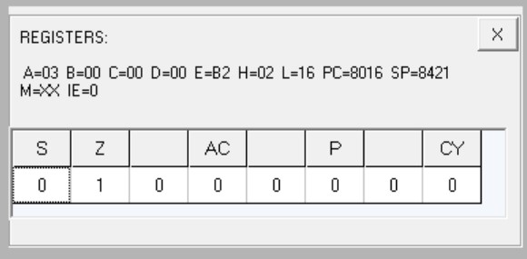

**Flag register output**

**Output at memory location 8600**

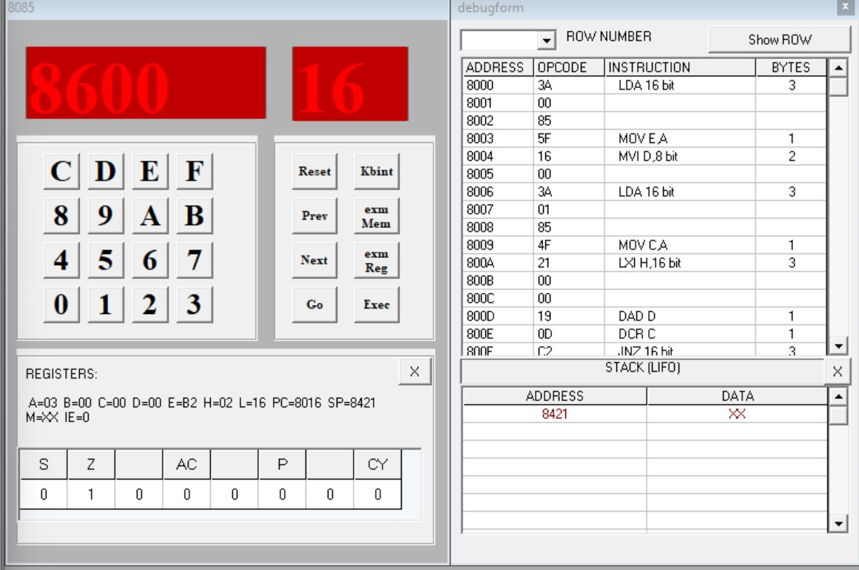

**Output at memory location 8601**

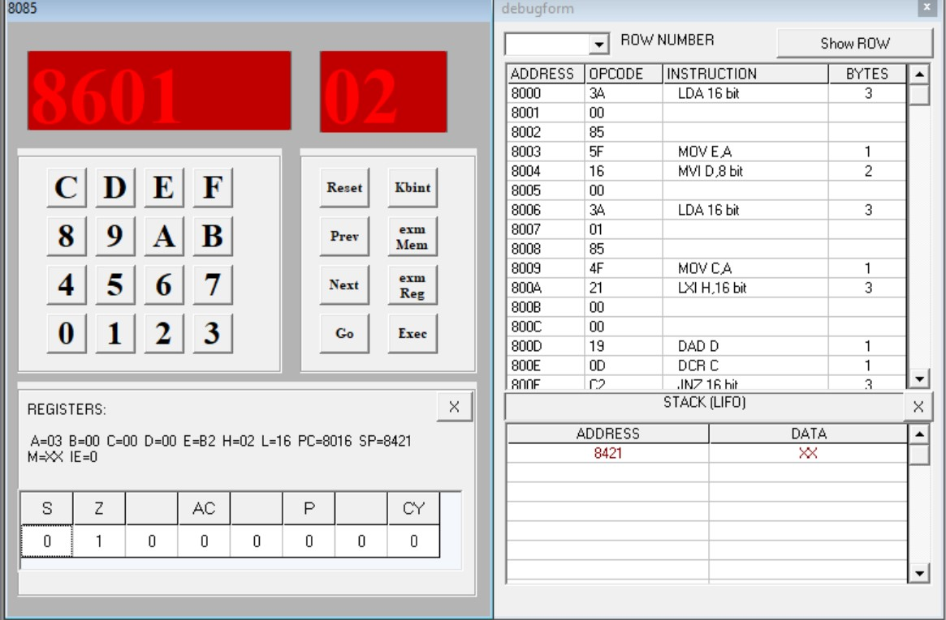

## Program 6

**Aim: Write a program to add ten 8-bit numbers. Assume the numbers are stored in 8500-8509. Store the result in 850A and 850B memory address.**

|  |  |  |
| --- | --- | --- |
| **Code** | **Memory Location** | **Opcode** |
| MVI C, 00 | 8000, 8001 | 0E, 00 |
| MVI B, 09 | 8002, 8003 | 06, 09 |
| LXI H, 8500H | 8004, 8005, 8006 | 21, 00, 85 |
| MOV A, M | 8007 | 7E |
| Back: INX H | 8008 | 23 |
| ADD M | 8009 | 86 |
| JNC Next | 800A, 800B, 800C | D2, 0E, 80 |
| INR C | 800D | 0C |
| Next: DCR B | 800E | 05 |
| JNZ Back | 800F, 8010, 8011 | C2, 08, 80 |
| INX H | 8012 | 23 |
| MOV M, A | 8013 | 77 |
| INX H | 8014 | 23 |
| MOV M, C | 8015 | 71 |
| RST 5 | 8016 | EF |

## Instruction set

**Input**

[8500] – FF, [8501] – 01, [8502] – 01, [8503] – 01, [8504] – 01, [8505] – 01, [8506] – 01,

[8507] – 01, [8508] – 01, [8509] – 01

**Output**

[850A] – 08, [850B] – 01

**Flag register output**

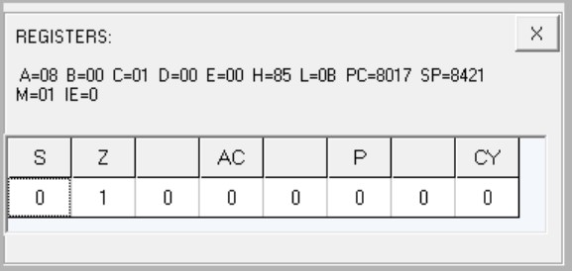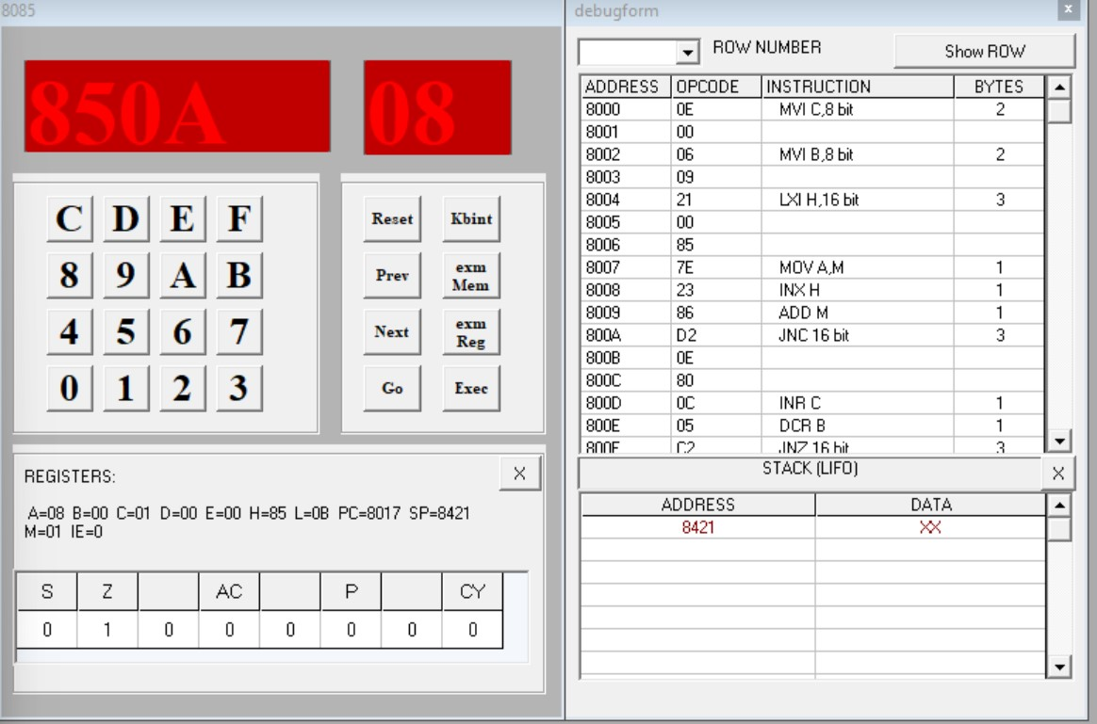

**Output at memory location 850A**

**Output at memory location 850B**

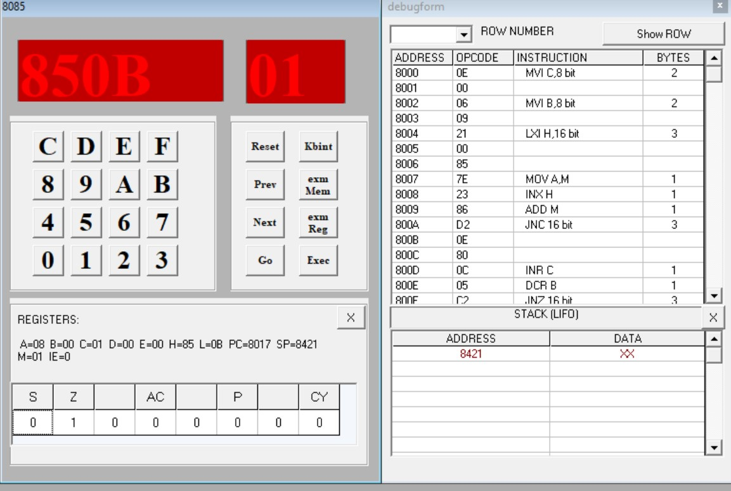

## Program 7

**Aim: Write a program to find the negative numbers in a block of data.**

|  |  |  |
| --- | --- | --- |
| **Code** | **Memory Location** | **Opcode** |
| LDA 8500H | 8000, 8001, 8002 | 3A, 00, 85 |
| MOV C, A | 8003 | 4F |
| MVI B, 00 | 8004, 8005 | 06, 00 |
| LXI H, 8501H | 8006, 8007, 8008 | 21, 01, 85 |
| Back: MOV A, M | 8009 | 7E |
| ANI 80H | 800A, 800B | E6, 80 |
| JZ Skip | 800C, 800D, 800E | CA, 10, 80 |
| INR B | 800F | 04 |
| Skip: INX H | 8010 | 23 |
| DCR C | 8011 | 0D |
| JNZ Back | 8012, 8013, 8014 | C2, 09, 80 |
| MOV A, B | 8015 | 78 |
| STA 8600H | 8016, 8017, 8018 | 32, 00, 86 |
| RST 5 | 8019 | EF |

## Instruction set

**Input**

[8500] – 04, [8501] – 56, [8502] – A9, [8503] – 73, [8504] – 82

**Output**

[8600] – 02

**Flag registers output**

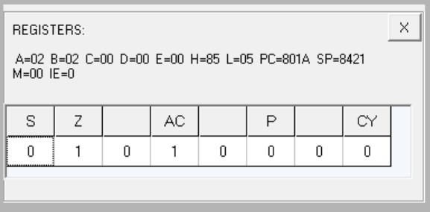

**Output at memory location 8600**

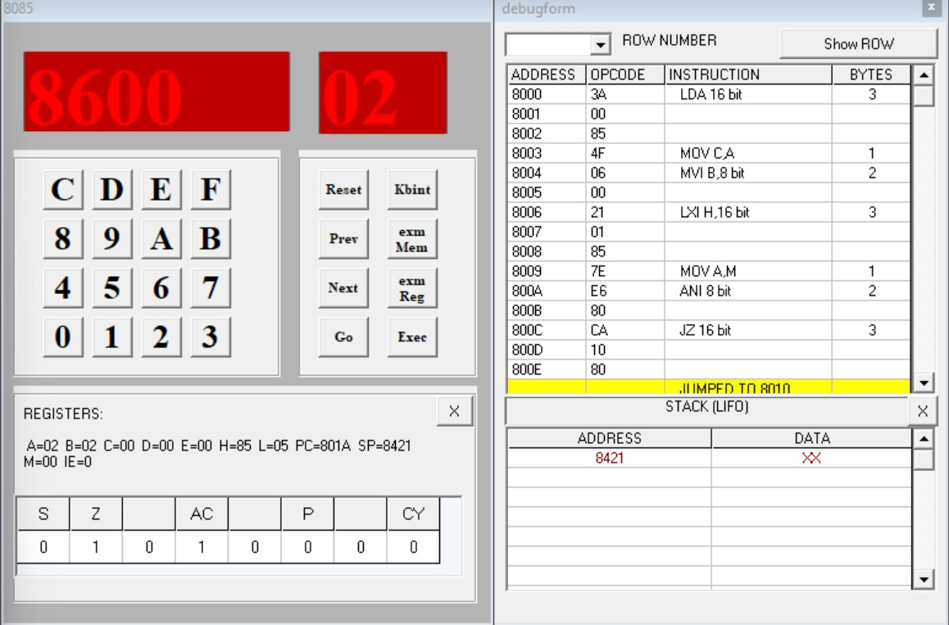

## Program 8

**Aim: Write a program to count the number of one’s in a number.**

|  |  |  |
| --- | --- | --- |
| **Code** | **Memory Location** | **Opcode** |
| LDA 8500H | 8000, 8001, 8002 | 3A, 00, 85 |
| MVI B, 08 | 8003, 8004 | 06, 08 |
| MVI D, 00 | 8005, 8006 | 16, 00 |
| Loop1: RLC | 8007 | 07 |
| JNC Loop2 | 8008, 8009, 800A | D2, 0C, 80 |
| INR D | 800B | 14 |
| Loop2: DCR B | 800C | 05 |
| JNZ Loop1 | 800D, 800E, 800F | C2, 07, 80 |
| MOV A,D | 8010 | 7A |
| STA 8600H | 8011, 8012, 8013 | 32, 00, 86 |
| RST 5 | 8014 | EF |

**Input**

[8500] - 25 0010 0101

**Output**

[8600] - 03

**Flag registers output**

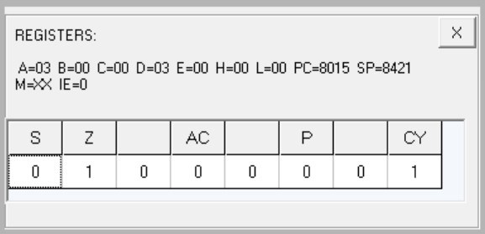

**Output at memory location 8600**

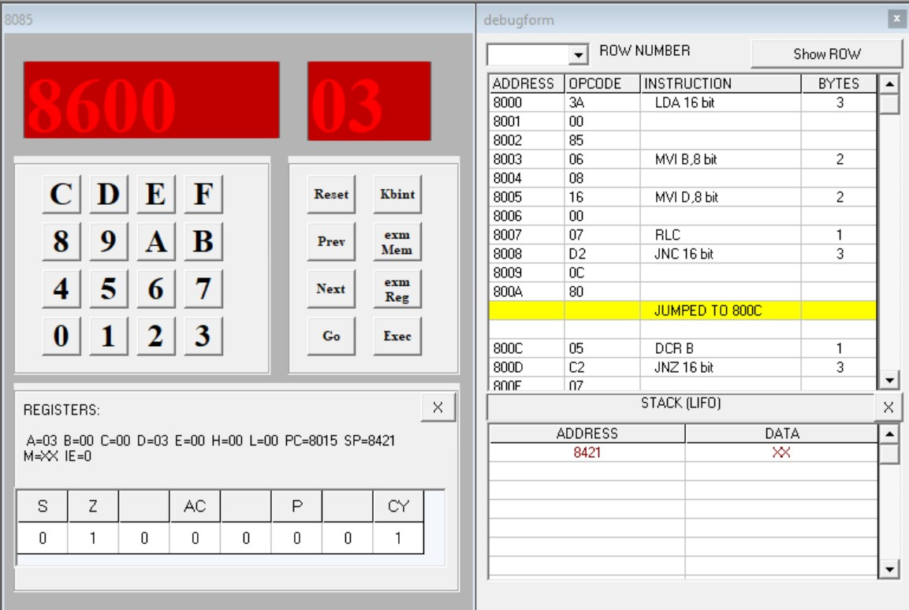

## Program 9

**Aim: Write a program to arrange numbers in Ascending order.**

|  |  |  |
| --- | --- | --- |
| **Code** | **Memory Location** | **Opcode** |
| LXI H, 8500H | 8000, 8001, 8002 | 21, 00, 85 |
| MOV C. M | 8003 | 4E |
| DCR C | 8004 | 0D |
| Repeat: MOV D, C | 8005 | 51 |
| LXI H, 8501H | 8006, 8007, 8008 | 21, 01, 85 |
| Loop: MOV A, M | 8009 | 7E |
| INX H | 800A | 23 |
| CMP M | 800B | BE |
| JC Skip | 800C, 800D, 800E | DA, 14, 80 |
| MOV B, M | 800F | 46 |
| MOV M, A | 8010 | 77 |
| DCX H | 8011 | 2B |
| MOV M, B | 8012 | 70 |
| INX H | 8013 | 23 |
| Skip: DCR D | 8014 | 15 |
| JNZ Loop | 8015, 8016, 8017 | C2, 09, 80 |
| DCR C | 8018 | 0D |
| JNZ Repeat | 8019, 801A, 801B | C2, 05, 80 |
| RST 5 | 801C | EF |

**Input**

[8500] - 05, [8501] - 05, [8502] - 04, [8503] - 03, [8504] - 02, [8505] - 01

**Output**

[8500] - 05, [8501] - 01, [8502] - 02, [8503] - 03, [8504] - 04, [8505] - 05

**Flag registers output**

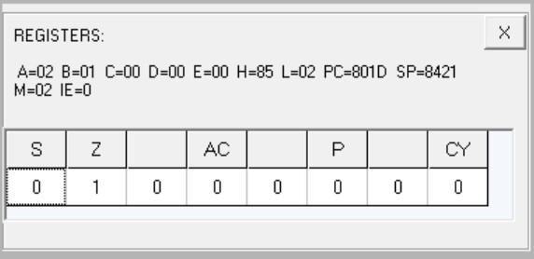

**Output at memory location 8500**

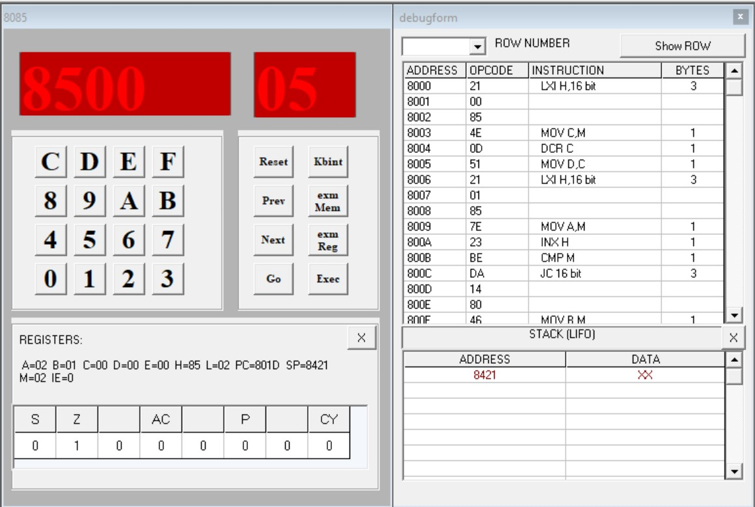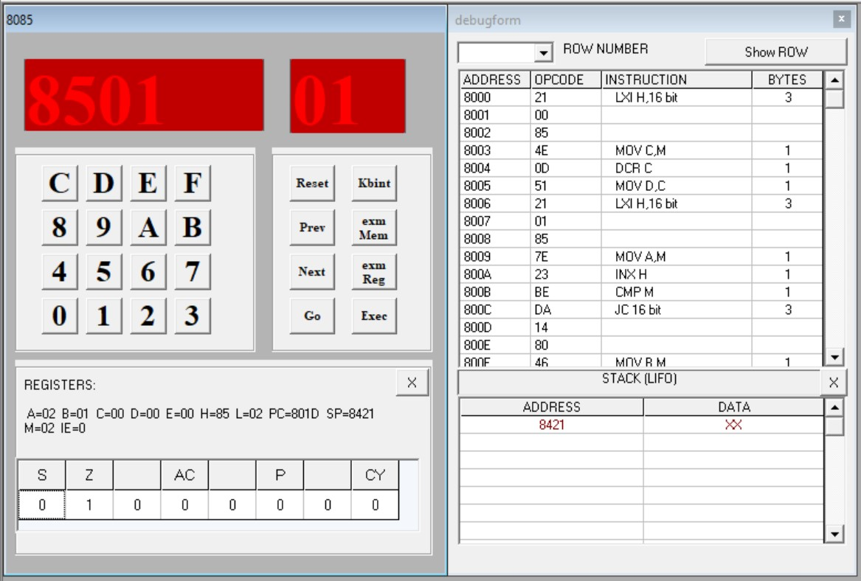

**Output at memory location 8501**

**Output at memory location 8502**

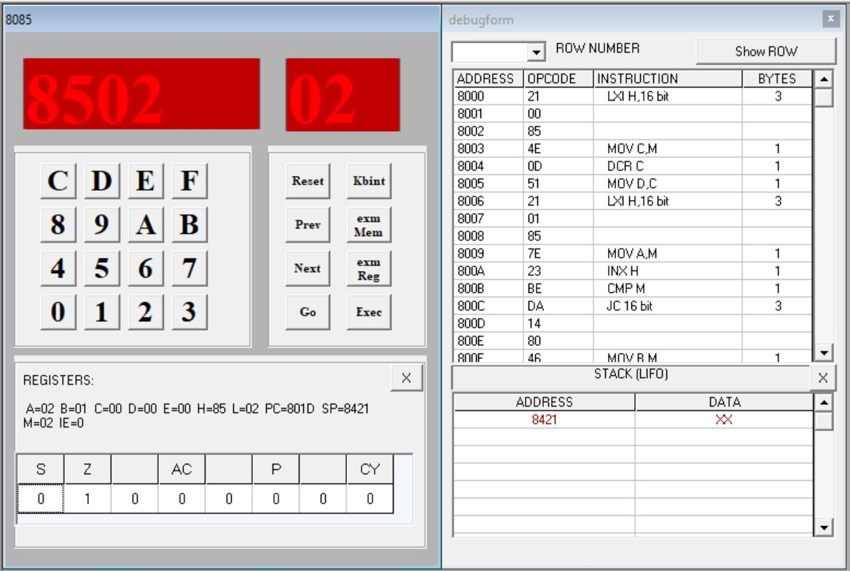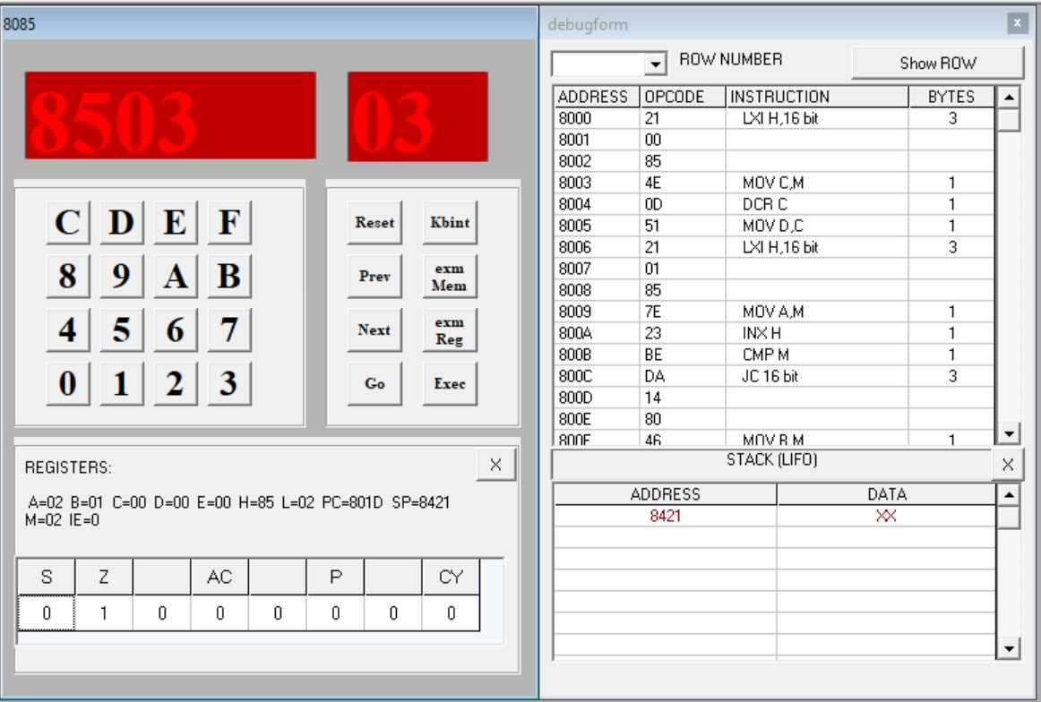

**Output at memory location 8503**

**Output at memory location 8504**

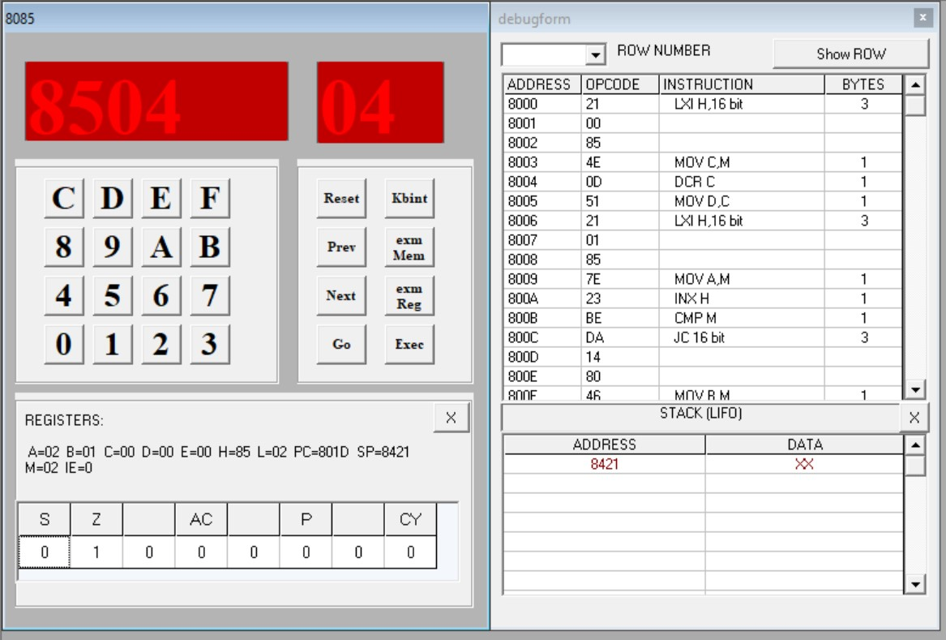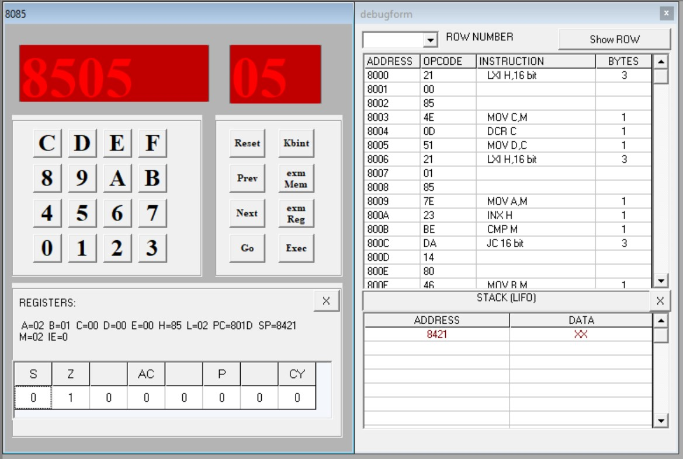

**Output at memory location 8505** **Program 10**

**Aim: Write a program to calculate the sum of series of even numbers.**

|  |  |  |
| --- | --- | --- |
| **Code** | **Memory Location** | **Opcode** |
| LDA 8500H | 8000, 8001, 8002 | 3A, 00, 85 |
| MOV C, A | 8003 | 4F |
| MVI B, 00 | 8004, 8005 | 06, 00 |
| LXI H, 8501H | 8006, 8007, 8008 | 21, 01, 85 |
| Back: MOV A, M | 8009 | 7E |
| ANI 01 | 800A, 800B | E6, 01 |
| JNZ Skip | 800C, 800D, 800E | C2, 12, 80 |
| MOV A, B | 800F | 78 |
| ADD M | 8010 | 86 |
| MOV B, A | 8011 | 47 |
| Skip: INX H | 8012 | 23 |
| DCR C | 8013 | 0D |
| JNZ Back | 8014, 8015, 8016 | C2, 09, 80 |
| STA 8600H | 8017, 8018, 8019 | 32, 00, 86 |
| RST 5 | 801A | EF |

**Input**

[8500] - 04, [8501] - 20, [8502] - 15, [8503] - 13, [8504] - 22

**Output**

42

**Flag registers output**

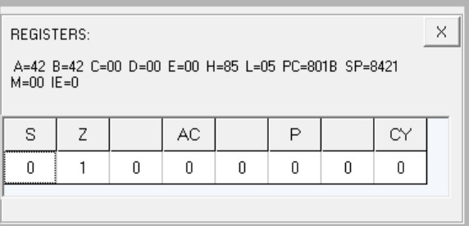

**Output at memory location 8600**

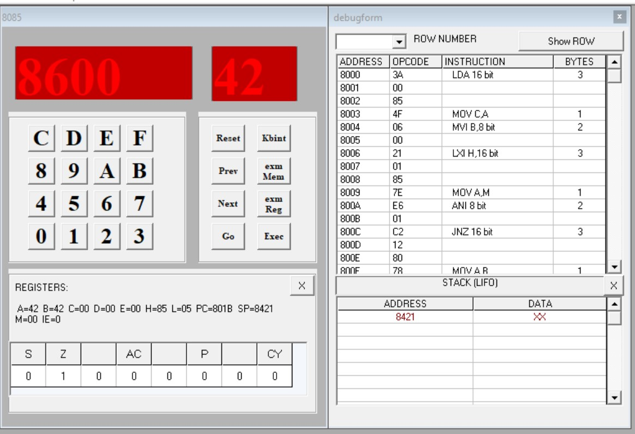

## Program 11

**Aim: Write an assembly language program to verify how many bytes are present in a given set, which resembles 10101101 in 8085.**

|  |  |  |
| --- | --- | --- |
| **Code** | **Memory Location** | **Opcode** |
| MVI B, 0A | 8000, 8001 | 06, 0A |
| MVI D, AD | 8002, 8003 | 16, AD |
| MVI C, 00 | 8004, 8005 | 0E, 00 |
| LXI H, 8500H | 8006, 8007, 8008 | 21, 00, 85 |
| Back: MOV A, M | 8009 | 7E |
| CMP D | 800A | BA |
| JNZ Next | 800B, 800C, 800D | C2, 0F, 80 |
| INR C | 800E | 0C |
| Next: INX H | 800F | 23 |
| DCR B | 8010 | 05 |
| JNZ Back | 8011, 8012, 8013 | C2, 09, 80 |
| MOV A, C | 8014 | 79 |
| STA 8600H | 8015, 8016, 8017 | 32, 00, 86 |
| RST 5 | 8018 | EF |

**Input**

[8500] - AD, [8501] - 01, [8502] - 01, [8503] - 01, [8504] - 01, [8505] - 01, [8506] - 01, [8507] - 01, [8508] - 01, [8509] - 01

**Output**

01

**Flag registers output**

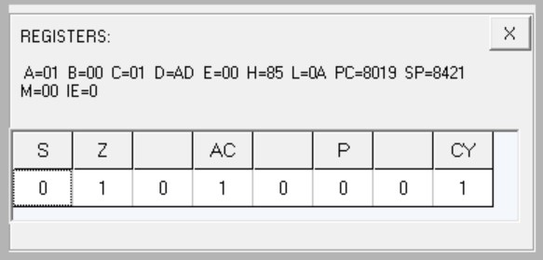

**Output at memory location 8600**

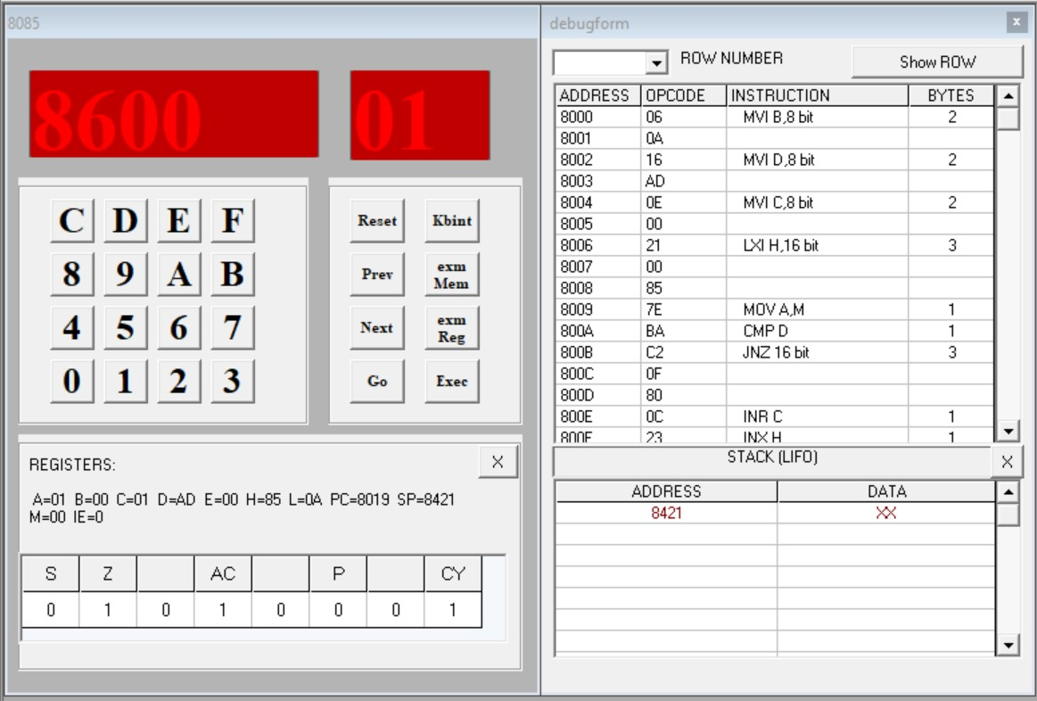

## Program 12

Aim: Write a assembly language program to find the numbers of even parity in ten consecutive memory locations in 8085.

|  |  |  |
| --- | --- | --- |
| **Code** | **Memory Location** | **Opcode** |
| MVI B, 0A | 8000, 8001 | 06, 0A |
| MVI C, 00 | 8002, 8003 | 0E, 00 |
| LXI H, 8500H | 8004, 8005, 8006 | 21, 00, 85 |
| Back: MOV A, M | 8007 | 7E |
| ANI FF | 8008, 8009 | E6, FF |
| JPO Next | 800A, 800B, 800C | E2, 0E, 80 |
| INR C | 800D | 0C |
| Next: INX H | 800E | 23 |
| DCR B | 800F | 05 |
| JNZ Back | 8010, 8011, 8012 | C2, 07, 80 |
| MOV A, C | 8013 | 79 |
| STA 8600H | 8014, 8015, 8016 | 32, 00, 86 |
| RST 5 | 8017 | EF |

**Input**

[8500] - 01, [8501] - 03, [8502] - 01, [8503] - 03, [8504] - 01, [8505] - 03, [8506] - 01, [8507] - 03, [8508] - 01, [8509] - 03

**Output**

05

**Flag registers output**

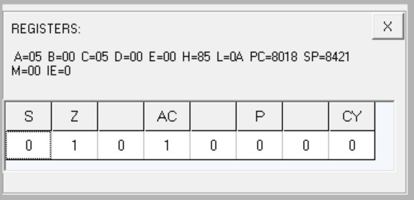

**Output at memory location 8600**

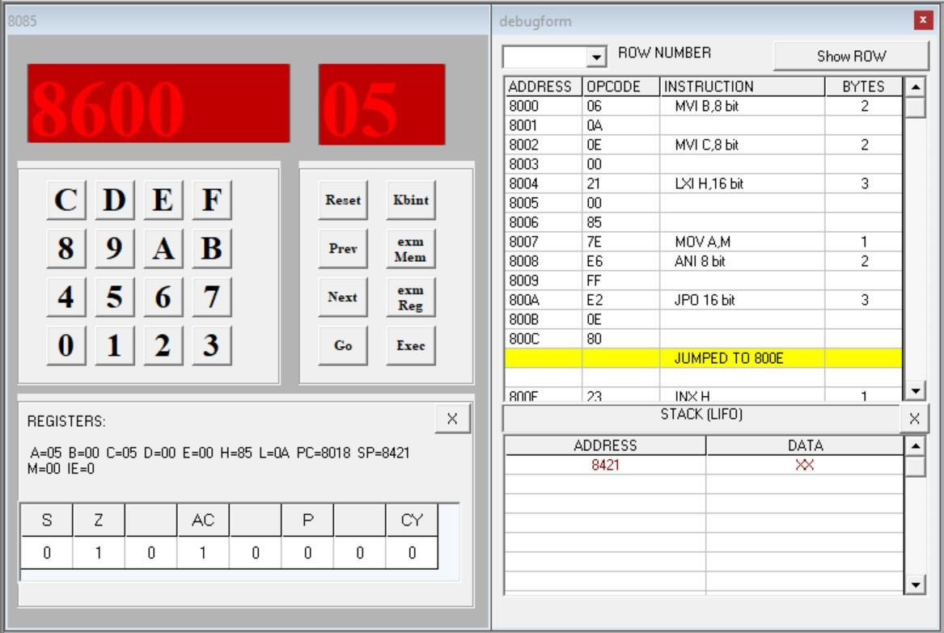

## Program 13

**Aim: Write an assembly language program to convert a BCD number into its equivalent binary in 8085.**

|  |  |  |
| --- | --- | --- |
| Code | Memory Location | Opcode |
| LDA 8500H | 8000, 8001, 8002 | 3A, 00, 85 |
| MOV B, A | 8003 | 47 |
| ANI 0F | 8004, 8005 | E6, 0F |
| MOV C, A | 8006 | 4F |
| MOV A, B | 8007 | 78 |
| ANI F0 | 8008, 8009 | E6, F0 |
| RRC | 800A | 0F |
| RRC | 800B | 0F |
| RRC | 800C | 0F |
| RRC | 800D | 0F |
| MOV B, A | 800E | 47 |
| XRA A | 800F | AF |
| MVI D, 0A | 8010, 8011 | 16, 0A |
| Sum: ADD D | 8012 | 82 |
| DCR B | 8013 | 05 |

|  |  |  |
| --- | --- | --- |
| JNZ Sum | 8014, 8015, 8016 | C2, 12, 80 |
| ADD C | 8017 | 81 |
| STA 8600H | 8018, 8019, 801A | 32, 00, 86 |
| RST 5 | 801B | EF |

**Input** [8500] - 67

**Output**

[8600] - 43

**Flag registers output**

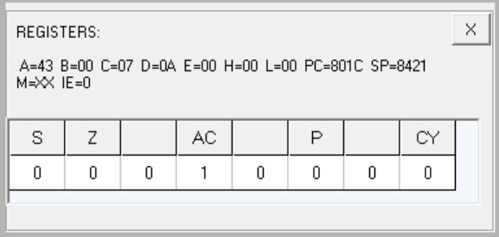

**Output at memory location 8600**

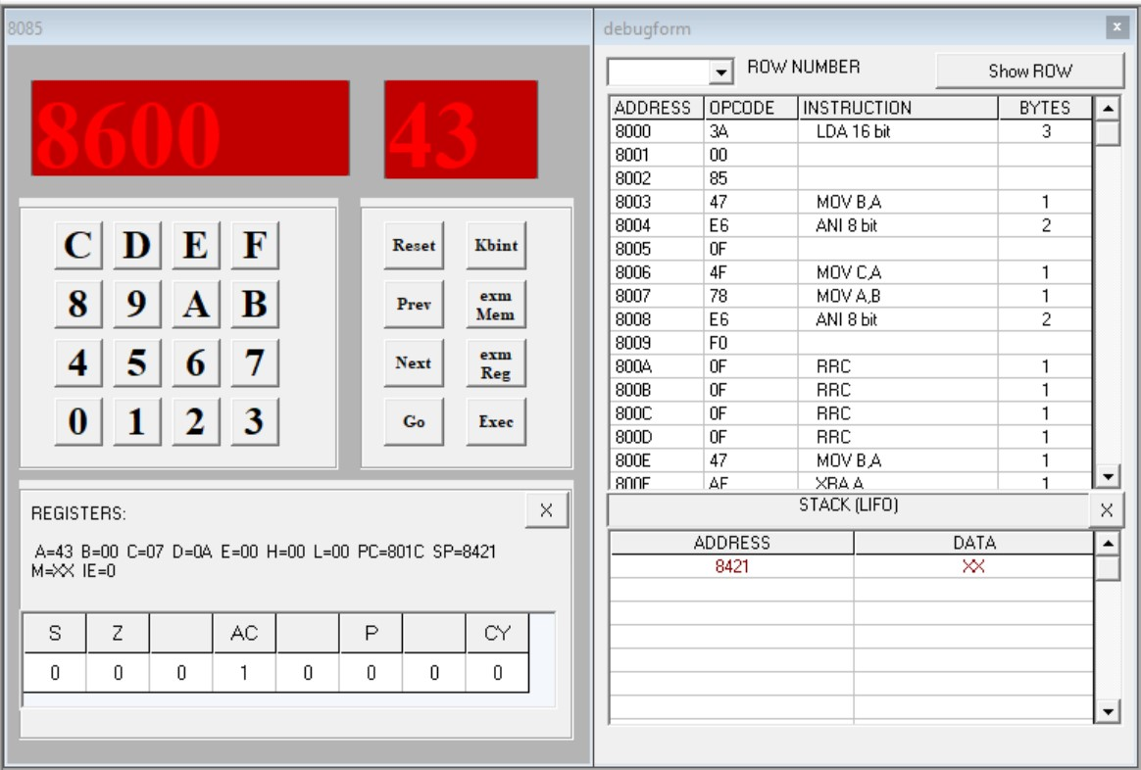

## Program 14

**Aim: Write an ALP for exchange the contents of memory location**

|  |  |  |
| --- | --- | --- |
| **Code** | **Memory Location** | **Opcode** |
| LDA 8500H | 8000, 8001, 8002 | 3A, 00, 85 |
| MOV B, A | 8003 | 47 |
| LDA 8600H | 8004, 8005, 8006 | 3A, 00, 86 |
| STA 8500H | 8007, 8008, 8009 | 32, 00, 85 |
| MOV A, B | 800A | 78 |
| STA 8600H | 800B, 800C, 800D | 32, 00, 86 |
| RST 5 | 800E | EF |

**Input**

[8500] - 48, [8600] - 88

**Output**

[8500] - 88, [8600] - 48

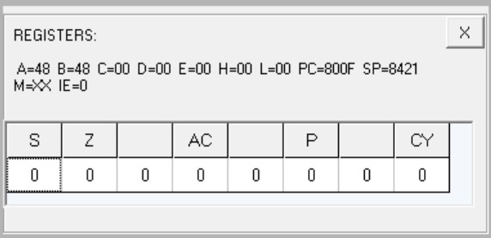

**Flag registers output**

**Output at memory location 8500**

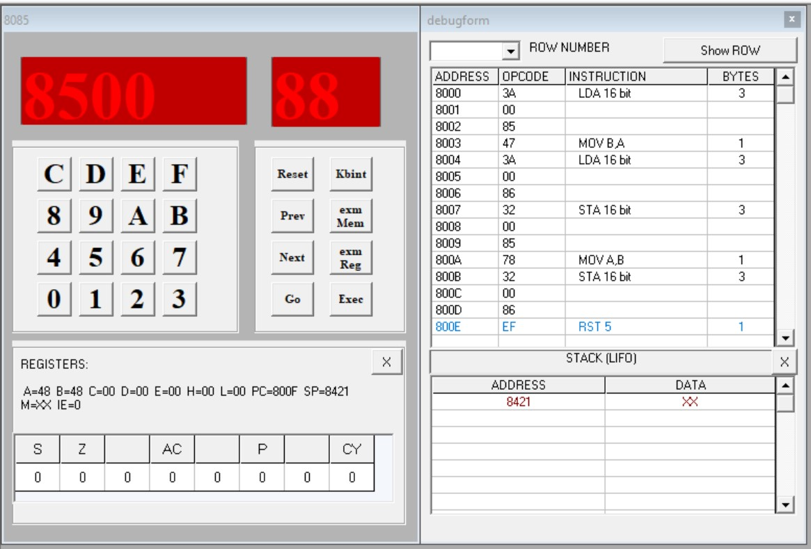

**Output at memory location 8600**

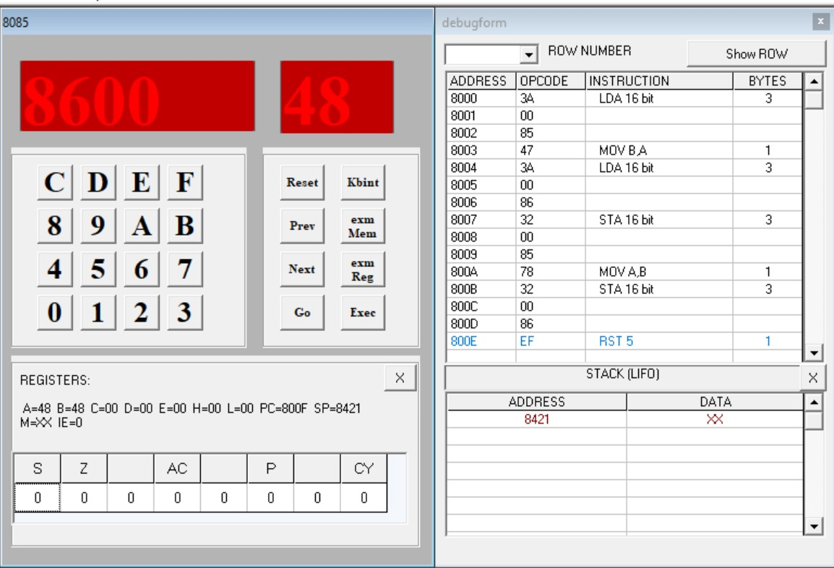

## Program 15

**Aim: Write a program to find the largest number in an array of 10 elements.**

|  |  |  |
| --- | --- | --- |
| **Code** | **Memory Location** | **Opcode** |
| MVI B, 09 | 8000, 8001 | 06, 09 |
| LXI H, 8500H | 8002, 8003, 8004 | 21, 00, 85 |
| MOV A, M | 8005 | 7E |
| INX H | 8006 | 23 |
| Back: CMP M | 8007 | BE |
| JNC Next | 8008, 8009, 800A | D2, 0C, 80 |
| MOV A, M | 800B | 7E |
| Next: INX H | 800C | 23 |
| DCR B | 800D | 05 |
| JNZ Back | 800E, 800F, 8010 | C2, 07, 80 |
| STA 850AH | 8011, 8012, 8013 | 32, 0A, 85 |
| RST 5 | 8014 | EF |

**Input**

[8500] - 01, [8501] - 02, [8502] - 03, [8503] - 04, [8504] - 05, [8505] - 06, [8506] - 07,

[8507] - 08, [8508] - 09, [8509] - 0A

**Output**

[850A] - 0A

**Flag registers output**

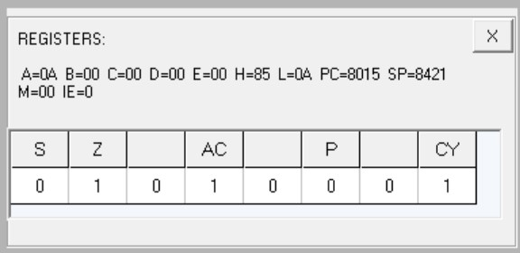

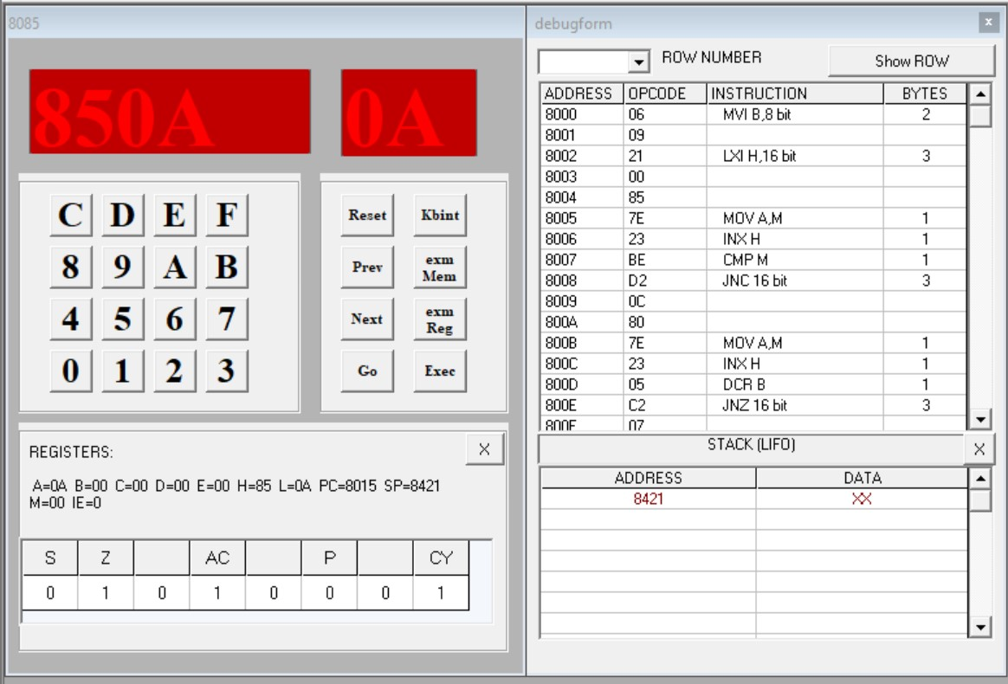

**Output at memory location 850A**

# Lab Assignment-1I (Intel 8086 Microprocessor)

**Table of Contents**

|  |  |  |
| --- | --- | --- |
| **S.no** | **Experiments** | **Page. No** |
| 1 | Write an assembly language program to add two 16-bit numbers in 8086. | 68 |
| 2 | Write an assembly language program to subtract two 16-bit numbers in 8086. | 70 |
| 3 | Write an assembly language program to multiply two 16-bit numbers in 8086. | 72 |
| 4 | Write an assembly language program to divide two 16-bit numbers in 8086. | 74 |
| 5 | Write an assembly language program to demonstrate AAA, AAS, AAM, AAD, DAA and DAS in 8086 | 76 |
| 6 | Write an assembly language program to find out the count of positive numbers and negative numbers from a series of signed numbers in 8086. | 80 |
| 7 | Write an assembly language program to convert to find out the largest number from a given unordered array of 8-bit numbers, stored in the locations starting from a known address in 8086. | 82 |
| 8 | Write an assembly language program to convert to find out the largest number from a given unordered array of 16-bit numbers, stored in the locations starting from a known address in 8086. | 84 |
| 9 | Write an assembly language program to print the Fibonacci series in 8086. | 86 |
| 10 | Write an assembly language program to perform the division 15/6 using the ASCII codes. Store the ASCII codes of the result in register DX. | 88 |

**EXPERIMENT NO: 1**

Write an assembly language program to add two 16-bit numbers in 8086.

**CODE:**

Code1: With fixed values Code2: With memory inputs

MOV BX, 1234h MOV BX, [1234h]

MOV CX, 5678h MOV AX, [1236h]

ADD BX, CX ADD AX, BX

HLT MOV [1238h], AX

HLT

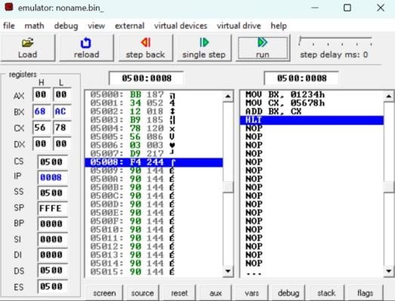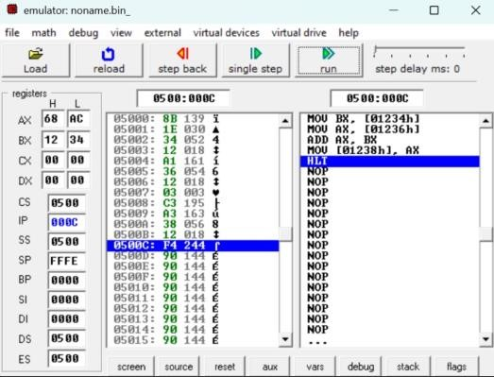

Fig 1.1.1 Output Form Fig 1.2.1 Output Form

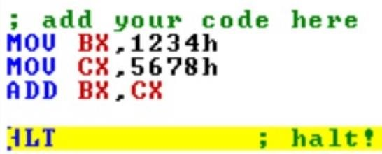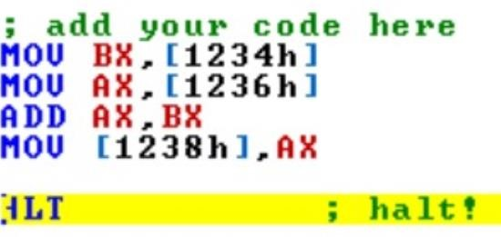

Fig 1.1.2 Code Explanation Fig 1.2.2 Code Explanation

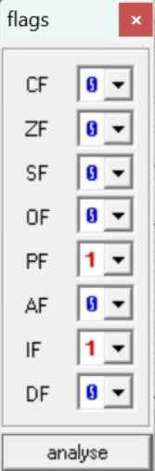

Fig 1.1.3 Flag Register Fig 1.2.3 Flag Register

Fig 1.2.4 Input and Output

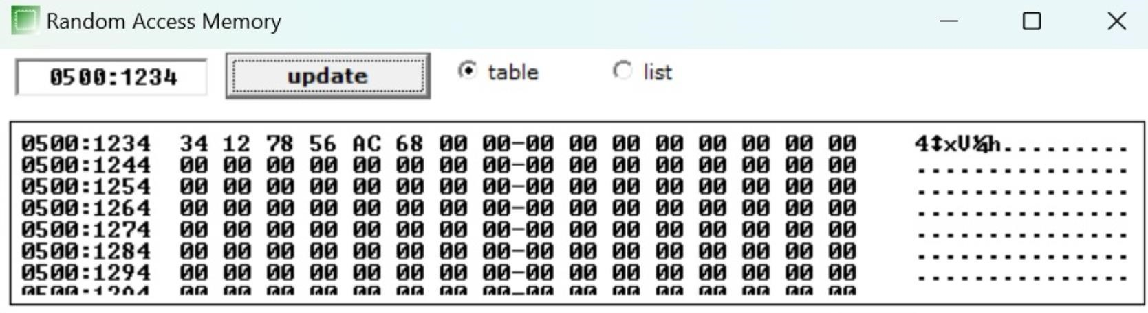

**2**

Write an assembly language program to subtract two 16-bit numbers in 8086.

**CODE:**

Code1: With fixed values Code2: With memory inputs

MOV BX, 1234h MOV BX, [1234h]

MOV CX, 5678h MOV AX, [1236h]

SUB CX, BX SUB AX, BX

HLT MOV [1238h], AX

HLT

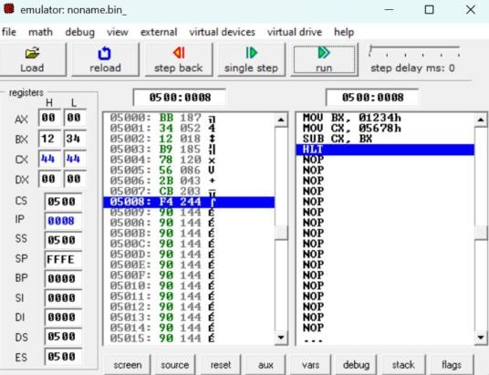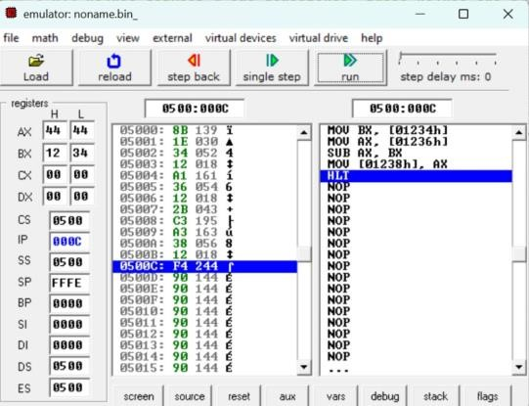

Fig 2.1.1 Output Form Fig 2.2.1 Output Form

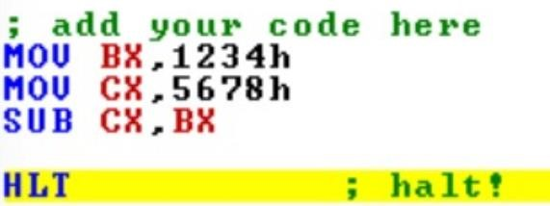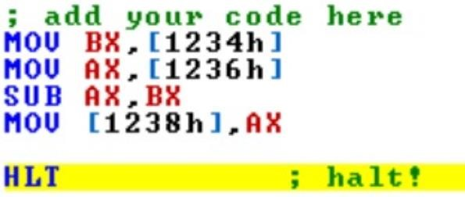

Fig 2.1.2 Code Explanation Fig 2.2.2 Code Explanation



Fig 2.1.3 Flag Register Fig 2.2.3 Flag Register

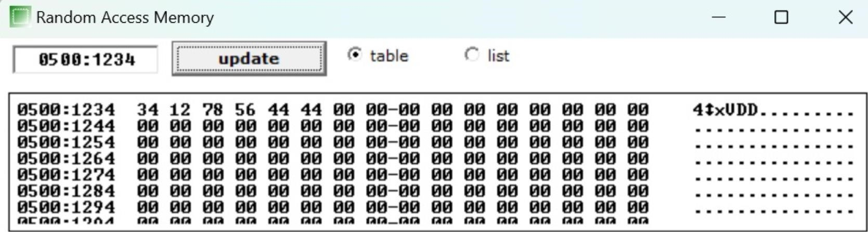

Fig 2.2.4 Input and Output

**3**

Write an assembly language program to multiply two 16-bit numbers in 8086.

**CODE:**

Code1: With fixed values Code2: With memory inputs

MOV BX, 1234h MOV BX, [1234h]

MOV AX, 5678h MOV AX, [1236h]

MUL BX MUL BX

HLT MOV [1238h], DX

MOV [123Ah], AX

HLT

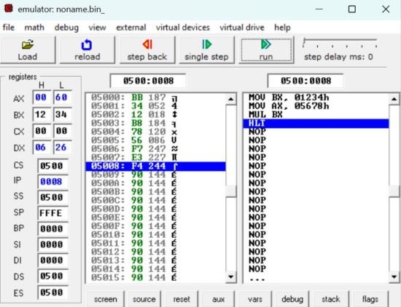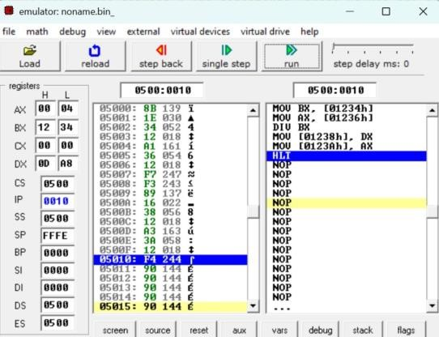

Fig 3.1.1 Output Form Fig 3.2.1 Output Form

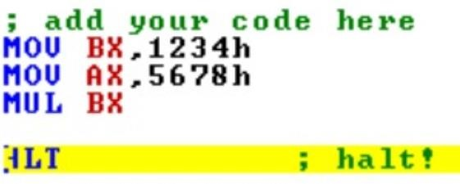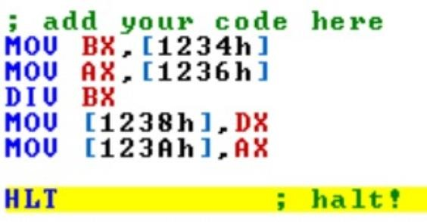

Fig 3.1.2 Code Explanation Fig 3.2.2 Code Explanation

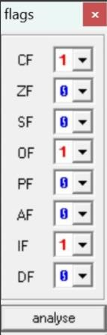

Fig 3.1.3 Flag Register Fig 3.2.3 Flag Register

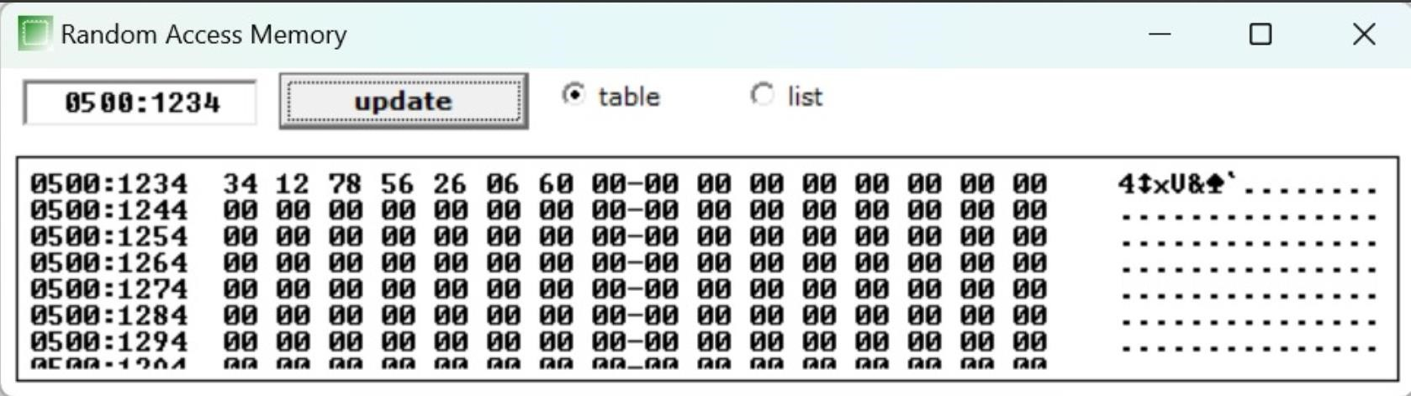

Fig 3.2.4 Input and Output

**4**

Write an assembly language program to divide two 16-bit numbers in 8086.

**CODE:**

Code1: With fixed values Code2: With memory inputs

MOV BX, 1234h MOV BX, [1234h]

MOV AX, 5678h MOV AX, [1236h]

DIV BX DIV BX

HLT MOV [1238h], DX

MOV [123Ah], AX

HLT

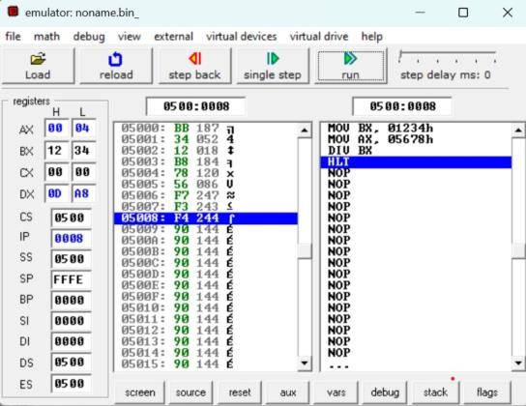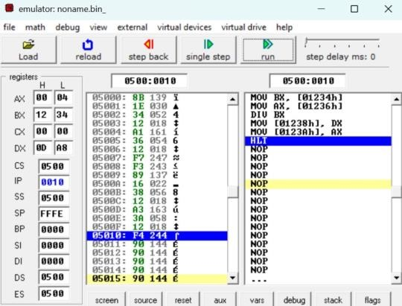

Fig 4.1.1 Output Form Fig 4.2.1 Output Form

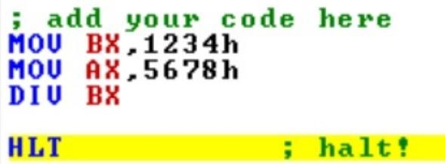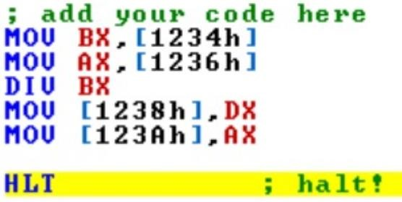

Fig 4.1.2 Code Explanation Fig 4.2.2 Code Explanation

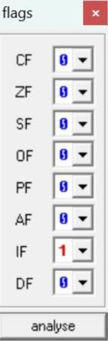

Fig 4.1.3 Flag Register Fig 4.2.3 Flag Register

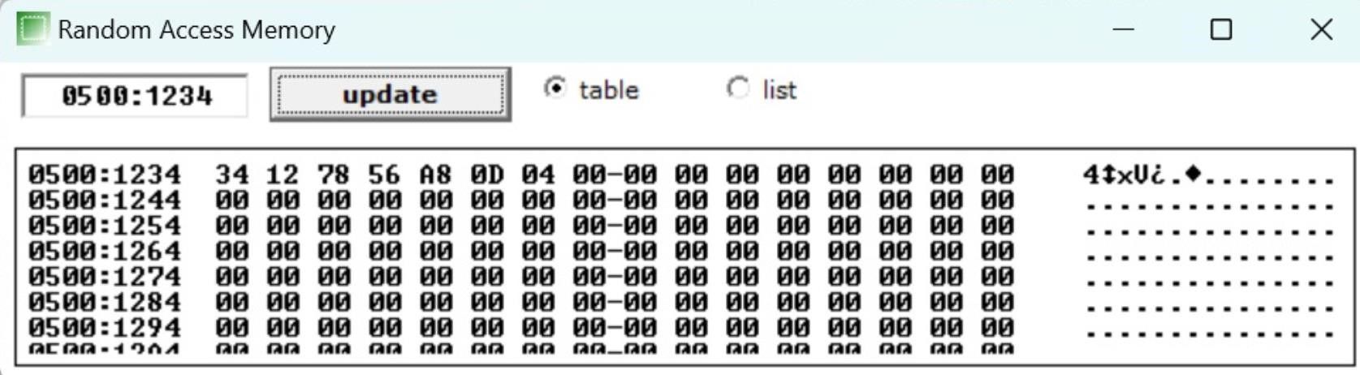

Fig 4.2.4 Input and Output

**5**

Write an assembly language program to demonstrate AAA, AAS, AAM, AAD, DAA and DAS in 8086

**CODE1:**

AAA AAS: AAM: AAD:

MOV AX, ‘6’ MOV AX, ‘3’ MOV AX, 5H MOV AX, 0AH

ADD AX, ‘7’ SUB AX, ‘9’ MOV BX, 7H MOV BX, 05H

AAA AAS MUL BX DIV BX

HLT HLT AAM AAD

HLT HLT

Code 5.1 Code 5.2 Code 5.3 Code 5.4

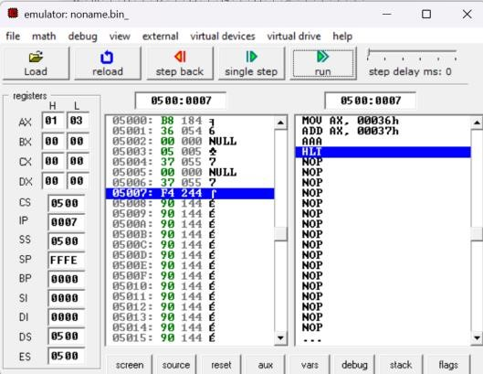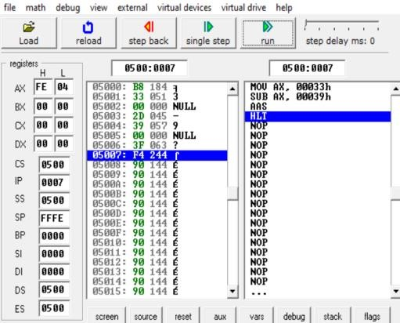

Fig 5.1.1 Output Form Fig 5.2.1 Output Form

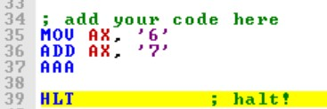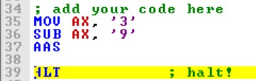

Fig 5.1.2 Code Explanation Fig 5.2.2 Code Explanation

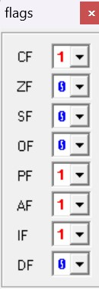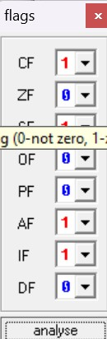

Fig 5.1.3 Flag Register Fig 5.2.3 Flag Register

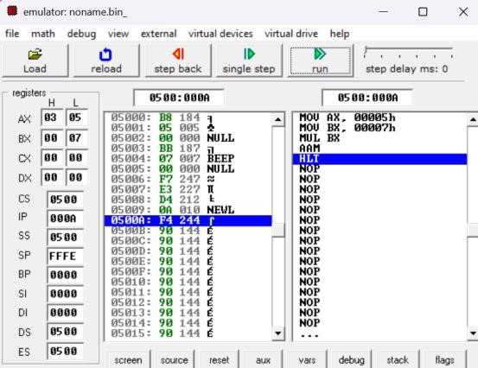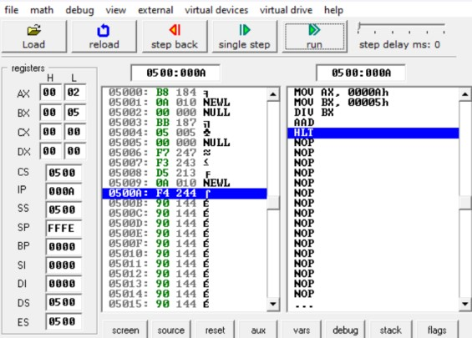

Fig 5.3.1 Output form Fig 5.4.1 Output Form

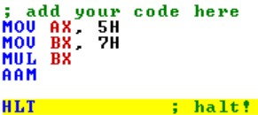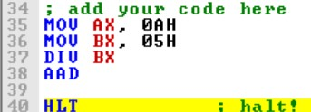

Fig 5.3.2 Code Explanation Fig 5.4.1 Code Explanation

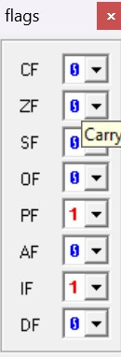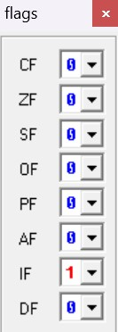

Fig 5.3.3 Flag Register Fig 5.4.3 Flag Register

**CODE2:**

DAA: DAS:

MOV AL, 71H MOV AL, 71H

ADD AL, 43H SUB AL, 43H

DAA DAS

HLT HLT

Code 5.5 Code 5.6

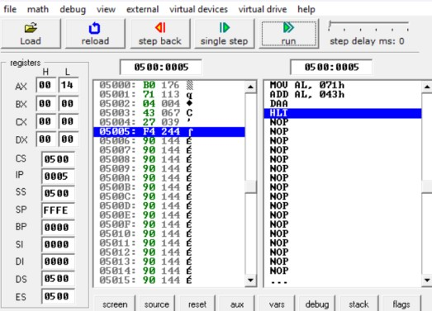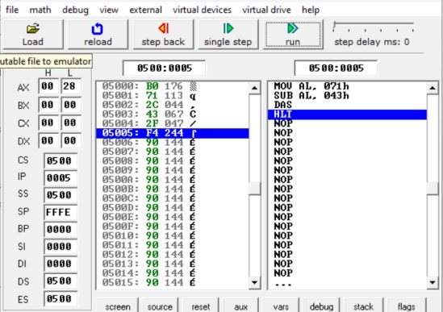

Fig 5.5.1: Output Form Fig 5.6.1: Output Form

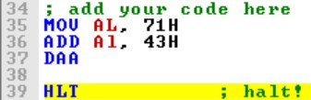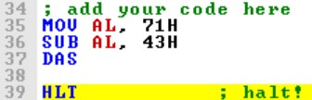

Fig 5.5.2: Code Explanation Fig 5.6.2: Code Explanation

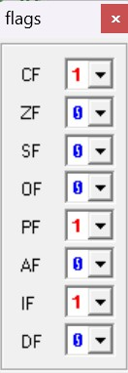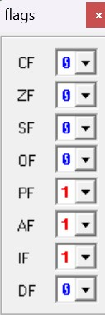

Fig 5.5.3: Flag Register Fig 5.6.3: Flag Register

**6**

Write an assembly language program to find out the count of positive numbers and negative numbers from a series of signed numbers in 8086.

**CODE:**

MOV CL, 0AH

MOV BL, 00H

MOV DL,00H

LEA SI,[1000H]

L1:MOV AL,[SI]

SHL AL,01

JNC L2

INC DL

JMP L3

L2: INC BL

L3: INC SI

DEC CL

JNZ L1

MOV [100AH],BL

MOV [100BH],DL

HLT

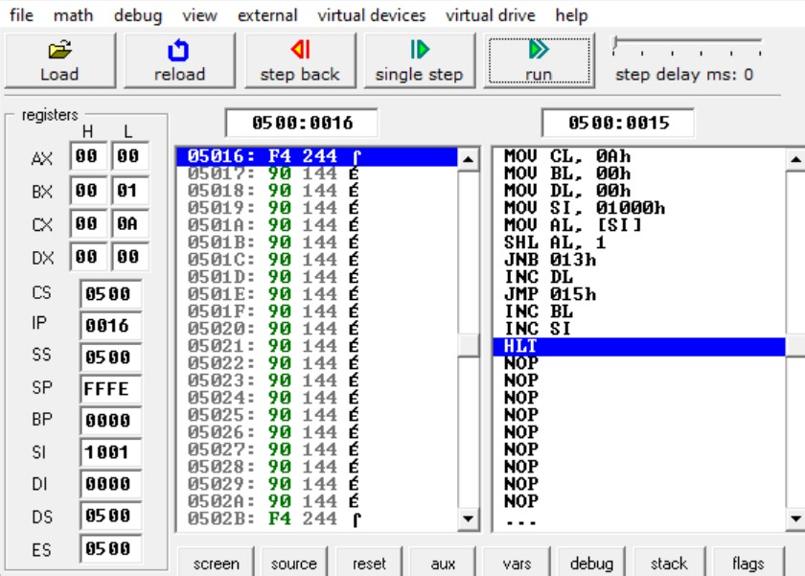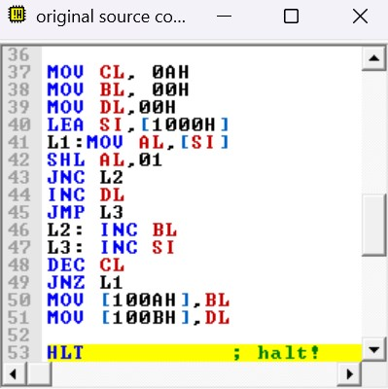

Fig 6.1 Output Form Fig 6.2 Code Explanation

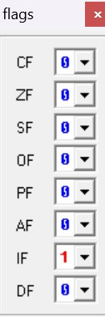

Fig 6.3 Flag Register

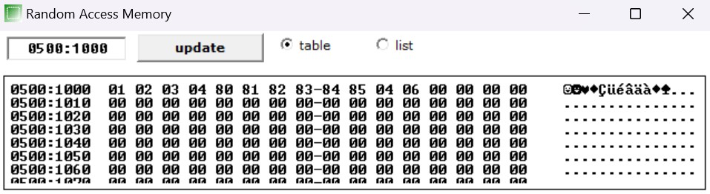

Fig 6.4: Input and Output

**7**

Write an assembly language program to convert to find out the largest number from a given unordered array of 8-bit numbers, stored in the locations starting from a known address in 8086.

**CODE:**

MOV CL, 0AH LEA SI,[1000H] MOV AL,[SI]

L1:INC SI

MOV BL,[SI]

CMP AL,BL

JC L2

JMP L3

L2: MOV AL,BL

L3: DEC CL

JNZ L1

MOV [100AH],AL

HLT

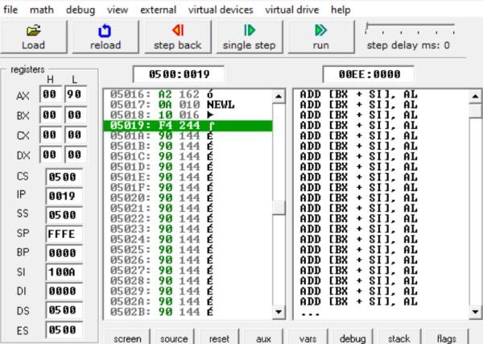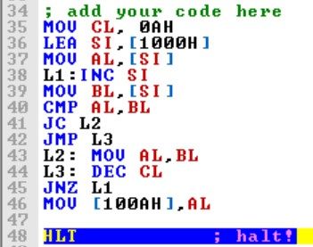

Fig 7.1: Output Form Fig 7.2 Code Explanation

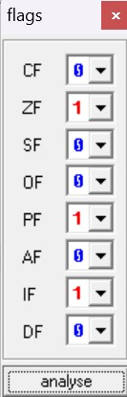

Fig 7.3: Flag Register

Fig 7.4: Input

And Output

Form

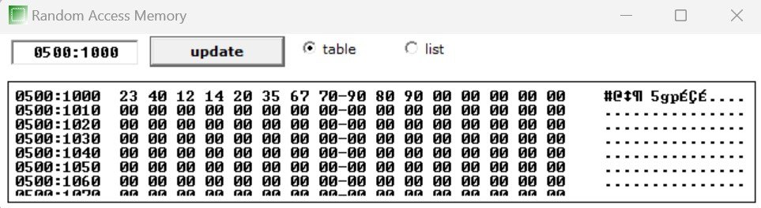

**8**

Write an assembly language program to convert to find out the largest number from a given unordered array of 16-bit numbers, stored in the locations starting from a known address in 8086.

**CODE:**

MOV CL, 0AH

MOV BX, 1000H

MOV CL, [BX]

INC BX

MOV AX, [BX]

DEC CL

BACK: INC BX

INC BX

CMP AX,[BX]

JNC Next

MOV AX, [BX]

Next: DEC CL

JNZ Back

MOV [1020H],AX

HLT

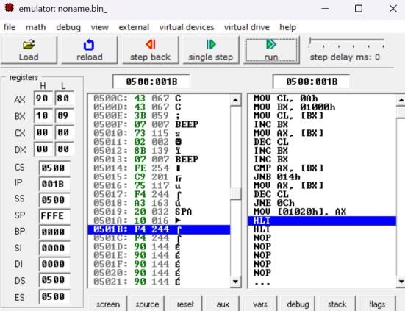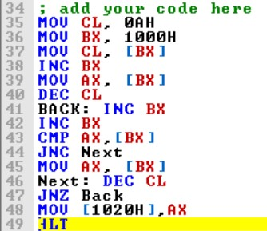

Fig 8.1: Output Form Fig 8.2: Code Explanation

Fig

8

.3:

Flag Register

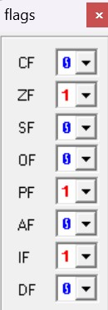

Fig

8

.4:

Input and Output Form

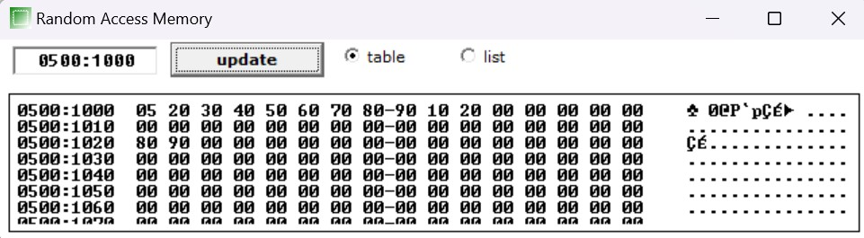

**9**

Write an assembly language program to print the Fibonacci series in 8086.

**CODE:**

MOV SI,3000H

MOV CX,0AH ;

XOR AL,AL

MOV [SI],0AH

INC SI

MOV [SI],00H

ADD AL,01H

INC SI

MOV [SI],AL

INC SI

MOV [SI],AL

Back: ADD AL,[SI]

INC SI

MOV [SI],AL

DEC SI

MOV AL,[SI]

INC SI

LOOP Back

HLT

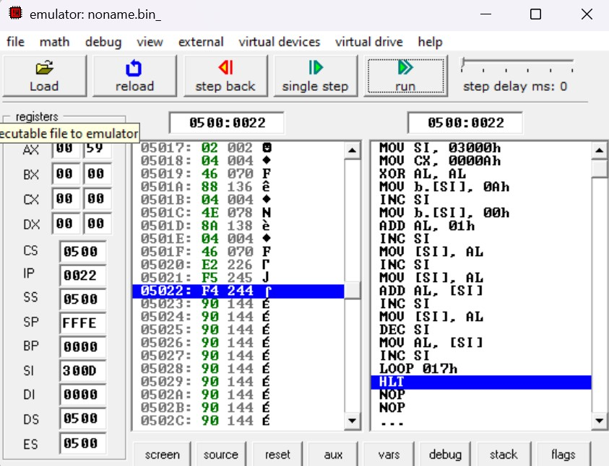 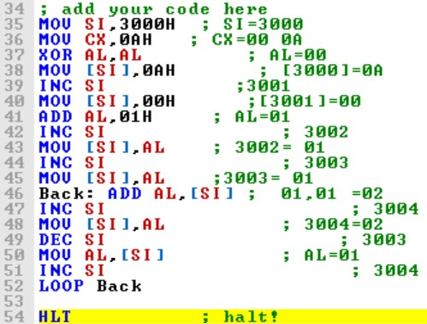

Fig 9.1: Output Form Fig 9.2: Code Explanation

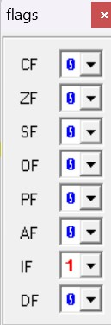

Fig 9.3: Flag Register

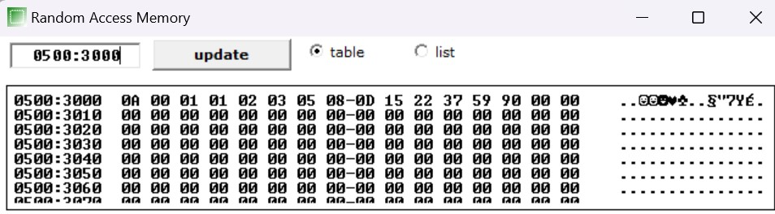

Fig 9.4: Input and Output form

**10**

Write an assembly language program to perform the division 15/6 using the ASCII codes. Store the ASCII codes of the result in register DX.

**CODE:**

MOV BH, '6'

SUB AX, 3030h

SUB BH, 30H AAD

DIV BH

ADD AX, 3030H

MOV DX, AX

HLT

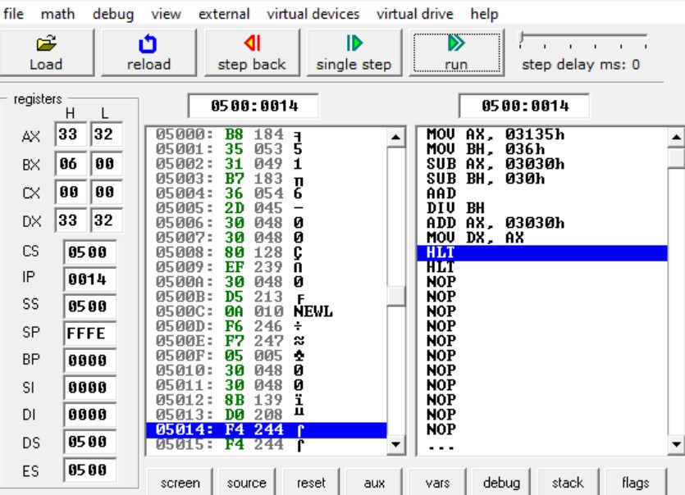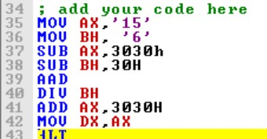

Fig 10.1: Output Form Fig 10.2: Code Explanation

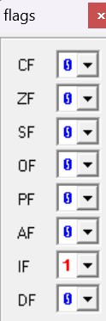

Fig 10.3: Flag Register